IMPROVING STUDENTS' CRITICAL THINKING SKILLS

USING THE INQUIRY LESSON MODEL

Noor Fadiawati*, Chansyanah Diawati, Galuh Catur Vishnu Prabowo
Program of Chemistry Education Studies, Faculty of Teacher Training in Education,
University of Lampung, Jl. Prof. Dr. Soemantri
Brodjonegoro No. 1 Bandar Lampung
*Email: noor.fadiawati@fkip.unila.ac.id

Abstract: This study aims to describe the effectiveness of the inquiry lesson model on the buffer solution material to improve students' critical thinking skills. The research sample was grade XI students of a senior highschool in Bandarlampung which obtained by using purposive sampling technique. In the control class, direct instruction learning was applied and in the experimental class was the inquiry lesson. The research used a quasi-experimental design with The Matching-Only Pretest- Post-test Control Group. The research data were analyzed using the n-gain calculation and parametric statistics with the t-test. The results showed that the post-test average score of critical thinking skills in the experimental class and the control class had a significant difference and the average n-gain in the experimental class was 0.48 (moderate category). Thus, it can be concluded that the Inquiry Lesson model is effective for improving students' critical thinking skills.

Key words: Inquiry lesson, buffer solution, critical thinking skills

Abstrak: Penelitian ini bertujuan untuk mendeskripsikan efektivitas model inquiry lesson pada materi larutan penyangga untuk meningkatkan keterampilan berpikir kritis siswa. Populasi dalam penelitian ini adalah seluruh siswa kelas XI IPA sebuah SMA Negeri di Bandarlampung yang diperoleh dengan teknik purposive sampling. Pada kelas kontrol diterapkan pembelajaran langsung dan pada kelas eksperimen diterapkan inquiry lesson. Metode penelitian yang digunakan adalah kuasi eksperimen dengan desain The Matching-Only Pre-test - Post-test Control Group. Data penelitian dianalisis menggunakan perhitungan n-gain dan statistik parametrik dengan uji t. Hasil penelitian menunjukkan bahwa skor rata-rata postes keterampilan berpikir kritis kelas eksperimen dan kelas kontrol memiliki perbedaan yang signifikan serta n-gain rata-rata di kelas eksperimen sebesar 0,48 (berkategori sedang). Dengan demikian, dapat disimpulkan bahwa model Inquiry Lesson efektif untuk meningkatkan keterampilan berpikir kritis siswa.

Kata kunci: Inquiry Lesson, larutan penyangga, keterampilan berpikir kritis

INTRODUCTION
In the era of the industrial revolution 4.0, there are several skills that are needed, namely communication skills, creativity, innovation, critical thinking, problem-solving, as well as collaboration (National Education Association, 2012). Critical thinking skills are considered the foundation of other skills, including communication, collaboration, global awareness, technology, life, and career skills, and learning and innovation abilities (Friedel, Irani, Rudd, Gallo, Eckhardt, & Ricketts, 2008). Critical thinking skills can be improved through education (Marjan, Arnyana & Setiawan, 2014), including the application of learning models (Mahardini et al., 2019; Trisdiono et al., 2019). In many subjects, one of the models that many examine its influence in improving critical thinking skills is inquiry learning (Fijar et al., 2019; Rusmansyah et al., 2019; Hasan et al., 2019; Wale & Bishaw, 2020; Aiman et al., 2020; Maknun, 2020; Nurdiansyah et al., 2021; Sari et al., 2021; Sutiani et al., 2021) Pre-experiments in the form of interviews with chemistry teachers in Bandarlampung showed that chemistry learning on buffer solution materials still applies many lecture methods with the help of powerpoint so that communication tends to occur one way only. For this reason, research was carried out as an alternative to improve students' thinking skills, especially in buffer solution materials.
The buffer solution is one of the materials in the class XI chemistry lesson in even semester with Basic Competency of Knowledge (KD 3.13) Analyzing the role of buffer solutions in the body of living beings and Basic Competency of Skills (KD 4.13) Designing, conducting and concluding, and examining the results of experiments to determine the properties of buffer solutions. To achieve the KD, students are required to go through a series of scientific processes such as observing, formulating problems, making observations, making hypotheses, conducting experiments, and drawing conclusions (Sund & Trowbridge, 1973; Bybee, 2006). The series of processes are in accordance with the inquiry lesson model because an inquiry lesson is a series of learning activities that involve the maximum of all students' abilities to search and investigate systematically, critically, logically, and analytically, so that they can formulate their own discoveries (Wenning, 2010). By applying the inquiry lesson model to the material, students automatically practice critical thinking in solving problems in the learning process. The critical thinking skills that are trained include simple explanations (elementary clarification), basic skills (basic support), inference, further explanation an (advance clarification), and making strategies and tactics. Therefore, Costa, 1985; Ennis, R., 1995,1996 the inquiry lesson is appropriate to be applied to the buffer solution material.
There are several studies related to learning with the inquiry lesson model. Based on the results of the study shows that inquiry lessons are effective in improving students' critical thinking skills on human excretion system materials (Susilowati, Sajidan, & Ramli, 2018), improving students' critical thinking ability on human immune system material (Elisanti et al., 2018), increase scientific creativity(Zulaichah et al., 2021), increase activity, creativity, critical thinking (Hasan et al., 2019), improve science literacy process dimensions and learning outcomes competencies skills in the material of the digestive system (Utomo, 2018), as well as improving the learning outcomes of chemistry on acid-base matter (Jauhariningsih, 2017). Based on the results of pre-experiments and literature studies, no one has studied the inquiry lesson model on the buffer solution material in improving students' critical thinking skills. Therefore, this study was conducted to recognize the Effectiveness of The Inquiry Lesson Model On Buffer Solution Materials To Improve Students' Critical Thinking Skills.

METHOD
This research involved 70 students in one of the Bandarlampung High Schools which consists of two classes, namely Class XI MIPA 2 with 35 students as the experimental class and Class XI MIPA 4 with 35 students as the control class. In the control class, the method used in learning was a lecture with the help of PowerPoint, while in the experimental class, an inquiry lesson model was used.
The types of data used in this study are main data and supporting data. The main data are test scores for critical thinking skills before the application of learning (pre-test) and test scores for critical thinking skills after the application of learning (posttest). Supporting data in the form of student activity data. The source of data in this study is all students in the control class and experimental class.
The method of this study is an experimental study using The Matching Only Pre-test-Post-test Control Group Design. Matching in this study is that the research subjects are not randomly assigned but by matching subjects who are in the experimental group with the control group on the research variables. The purpose of matching is to ensure that both groups are equivalent and homogeneous in the variable (Fraenkel et al., 2012). The outlines can be shown in Table 1.

Table 1. Research Design
Research Class | Treatment
Experiment | M | O | X | O
Control | M | O | C | O
Information:
M = Matching, which means that in this design there are matching samples
O = Pretes and postes given in both research classes
X = Treatment in the form of applying the Inquiry Lesson model
C = Control class with the application of lecture method learning

Before the treatment was applied, statistical matching was carried out in the control class and the experimental class by means of pretests. Then the pre-test results on the two study samples were statistically matched through a similarity test of two averages. Then in the experimental class, it was treated by applying the inquiry lesson model, and in the control class conventional learning was applied. Next, both classes are given a posttest. The research data were analyzed using n-gain calculations and parametric statistics with a t-test to see the effectiveness of the treatment given.

RESULTS AND DISCUSSION

The average score of the pre-test of students' critical thinking skills in the experimental class and control class can be seen in Figure 1.

Research classes
Figure 1. Pre-test average scores of students' critical thinking skills in control and experimental classes

Based on Figure 1, it is known that the average score of critical thinking skills pretests in the experimental class was 8.11, and in the control-class was 8.08. To find out whether the scores of students' critical thinking skills in these two classes did not differ significantly, a two-average similarity test was carried out, which had previously been tested for normality and homogeneity against students' pre-test scores in both research classes. The normality test is carried out by a chi-squared test with test criteria, accept H₀ if χ2 _{calculated} ≤ χ2 _{tables} with a level of α = 5%. After calculating the pre-test data of critical thinking skills, a score of χ2 _{calculated} and χ2 _{tables} can be obtained which can be seen in Table 2.
Table 2. Normality test results pre-test students' critical thinking skills
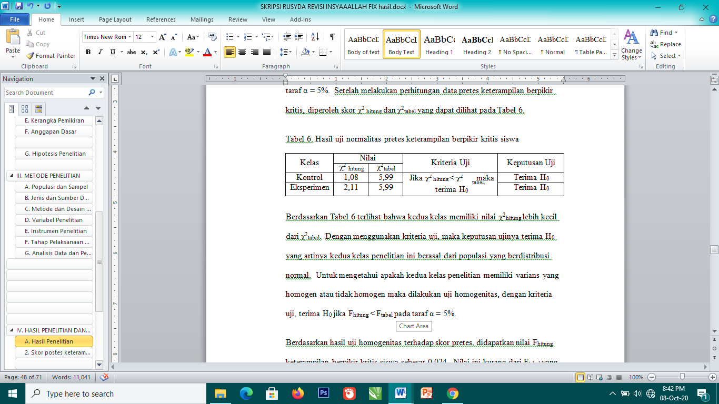

Based on Table 2, it appears that both classes have a value of χ2_{calculated} smaller than χ2_{table}. Using the test criteria, the test decision received H₀, which means that these two classes of studies came from normally distributed populations. To find out whether the two classes of studies have homogeneous or inhomogeneous variance, a homogeneity test was carried out, with test criteria, accepting H₀ if F_{counts} < F_{table} at the level of α = 5%.
Based on the results of the homogeneity test on the pre-test score, an F_{calculated} value for students' critical thinking skills was obtained at 0.024. This value is less than the F_{table} with a 3.98 correlation. So, the test decision is to accept H₀, that is, both research classes have homogeneous variances.
Based on the results of the normality and homogeneity test showing that the data were normally distributed and had a homogeneous variance, a two-average similarity test was carried out using a parametric test (t-test), with test criteria accept H₀ if t_{calculation} < t_{Table} with a degree of freedom d(k) = n1+ n2 – 2 at the level of α = 5%.
The results of the two average similarity tests obtained a t_{calculated} value of 1.28 and a t_{table} of 1.99. Based on the test criteria, it can be concluded that the test decision receives H₀, meaning that the average score of the pre-test of critical thinking skills of students in the experimental class is equal to the average score of the pre-test of students' critical thinking skills in the control class or both classes do not differ significantly. However, they are not significantly different, the two classes can be used as research classes.
The average score of post-tests of critical thinking skills of students in experimental classes and control classes is presented in Figure 2.

Research classes

Figure 2. Pre-test average scores of students' critical thinking skills in control and experimental classes

In Figure 2, it can be seen that the average score of critical thinking skills posts in the experimental class was 15.71 while the average score of critical thinking skill posttests in the control class was 13.65. This shows that students in the experimental class who were taught with the inquiry lesson model had a greater average score of critical thinking skills posttests than the average score of posttests critical thinking skills of control class students taught with conventional learning.
The inquiry lesson model is said to be effective if the average score of critical thinking skills Post-test in the experimental class is statistically greater than the average score of critical thinking skills post-test in the control class. To find out whether the average score of the post-test differs significantly or not statistically, hypothesis testing is carried out using a two-average difference test. Before the difference test of the two averages is carried out, a normality test and a homogeneity test are first carried out against the post-test score to find out the parametric or nonparametric test to be carried out. The normality test on the post-test of critical thinking skills of students in the experimental class was carried out with the Chi-Squared test, with the criteria of the test accepting H₀ if χ2_{calculated} ≤ χ2_{tables} with a level of α = 5%. Based on the results of the normality test on the post-test score, the scores of χ2_{calculated} and χ2_{tables} for students' critical thinking skills in the experimental class were presented in Table 2.

Table 3. Normality test results critical thinking skills post-test
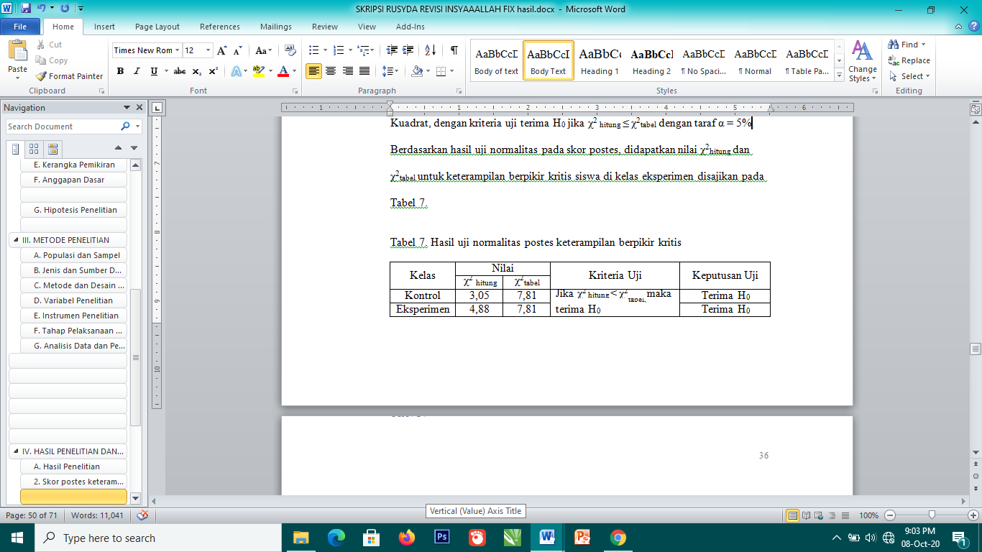

In Table 3 it is seen that the value of χ2_{calculated} the critical thinking skills of students in the experimental class and in the acquired control class is smaller than χ2_{table}. Based on the test criteria, the test decision received H₀ or in other words the post-test data of the two research classes, namely the control class and the expectation class came from the population normally distributed. To find out whether the two classes have homogeneous variances, a homogeneity test is carried out, with test criteria, accept H₀ if F _{calculated} < F_{table} at the level of real 5%.
Based on the results of the homogeneity test calculation of the post-test score, a F_{calculated} score for students' critical thinking skills was 2.32. The value is smaller than F_{table} which is 3.98. Then the test decision is to accept H₀, that is, both research classes have a homogeneous variance.
Based on the results of the normality test and homogeneity test showed that the two classes of the study came from a population that was normally distributed and had a homogeneous variance, a different test of two was carried out. average using a parametric test (t-test). The t-test has the criteria of the accepted test H₀ if t_{calculated} < t_{table} with degrees of freedom d(k) = n1 + n2 – 2 and the degree of α = 5%.
Based on the results of the two-average difference test, a t_{calculated} value for students’ critical thinking skills was obtained at 4.04. The value is greater than the t_{table} of 1.99. Based on the test criteria, it can be concluded that the post-test score data of the two classes reject H₀, meaning that the average score of post-test of critical thinking skills of students in the class applied by the inquiry lesson model is greater than the average score of the average score Post-test students' critical thinking skills in the classroom that conventional learning is applied so that it can be said that the inquiry lesson model is effective in improving students' critical thinking skills.
After obtaining data on students' pre-test and post-test scores of critical thinking skills, the data were used to calculate the n-gains of students in both research classes to see the improvement that occurred in students after the learning process. The average n-gain of critical thinking skills students is presented in Figure 3.

Research classes
Figure 3. n-gain the average creative thinking skills of students in control classes and experimental classes.

In Figure 3, it can be seen that the average n-gain of the experimental class is 0.48 which is medium category and the average n-gain of the control class is 0.29 low category. Based on the results of the n-gain calculation, it can be concluded that the inquiry lesson model is effective in improving students' critical thinking skills.
The improvement that occurs in each critical thinking indicator can be done by analyzing the average score of pre-tests and post-tests. In the analysis of the average score of pre-test and posttest, students in the experimental class experienced an improvement in each indicator of critical thinking skills. The critical thinking skills studied include the skills of clarifying the basics, searching for information, referring, as well as clarifying further. The average scores of pretests and posttests of students' creative thinking skills on each indicator in the experimental class can be seen in Figure 4.

Skill indicators
critical thinking
Information
1. Basic clarification
2. Seeking Information
3. Inference
4. Consider
credibility of sources

Figure 4. The average score of the pre-tests and post-test of each critical thinking indicator

Before
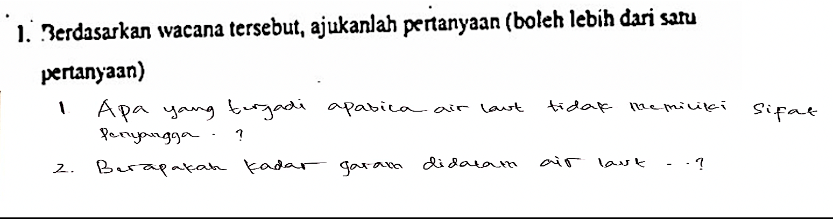
After
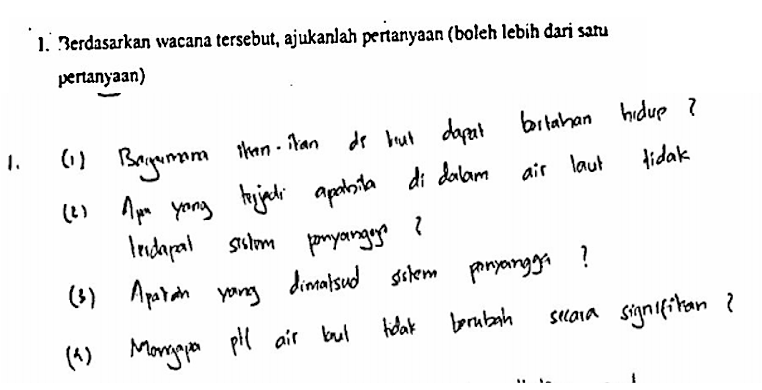

Figure 5. Basic Clarifying Skills Before and After Guidance.

Based on Figure 4, it can be seen that all indicators have improved compared to before learning. In Figure 5, it can be seen that the increase in students' ability in this case is the ability to ask questions. Zubaidah (2017) revealed the characteristics of a person who has critical thinking skills, one of which is that they can raise important questions and problems and formulate them clearly and just right. At this stage, students read the discourse given by the teacher, namely about buffer solutions in seawater and about the problem of consuming acid food and alkaline food. After reading the discourse, students write questions about what things they do not yet understand. After students are guided in the process of identifying problems and understanding the root causes in the discourse, students will better understand how to make appropriate and directed questions. Likewise, for the second indicator, namely the stage of finding information and considering the credibility of sources of information, students are more targeted in exploring information that is in accordance with the previously asked questions with credible sources as shown in Figure 6.

Before
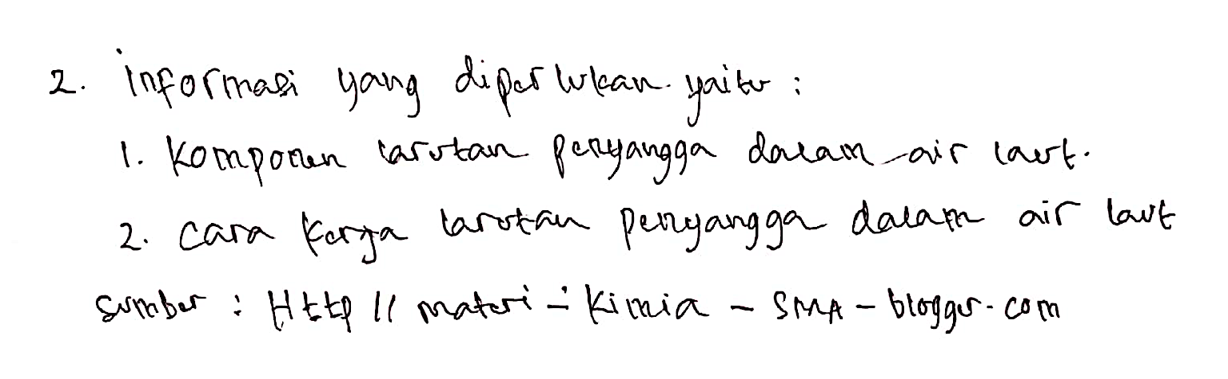
After
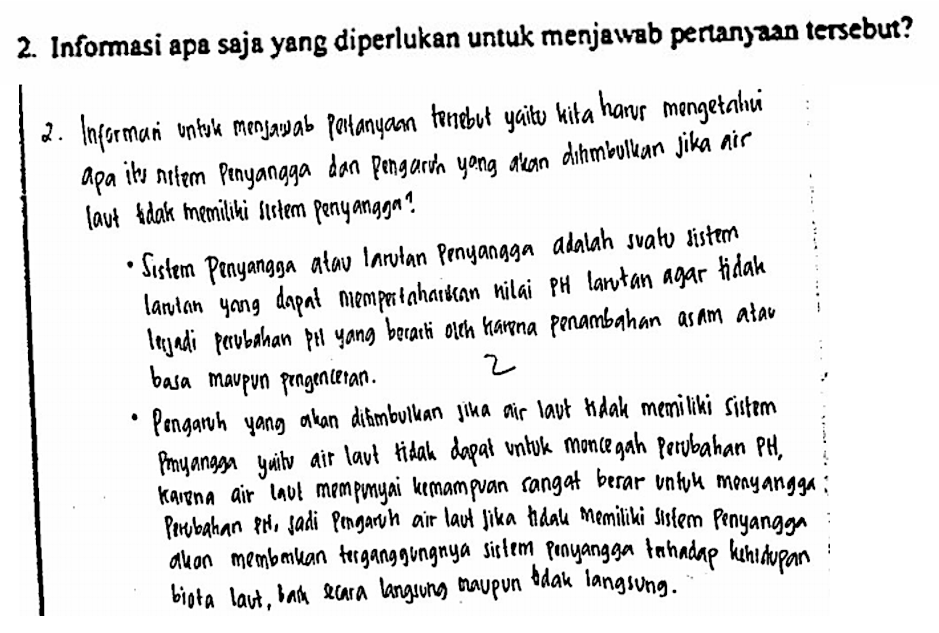

Figure 6. Skills to Gather Information Before and After Guidance

Students conduct literature studies by reading other people's research related to the nature of buffers in seawater, in addition to that, students also conduct buffer solution experiments/ experiments. This allows students to combine their old knowledge with new knowledge and develop information-gathering skills (Akinoglu & Tandogan, 2007).
The skill of referring has increased the most compared to the skills of seeking information, inference, and considering the credibility of sources as shown in Figure 7. This is because the complexity of the thinking skills used is simpler. At this stage, students carry out information processing to find the relationship between one information and another, so that they can draw various conclusions from the linkage of information said (Asabe & Joseph, 2016). This increase in ability can be seen in the suitability and accuracy of the conclusions made with the objectives of the experiment.

Before
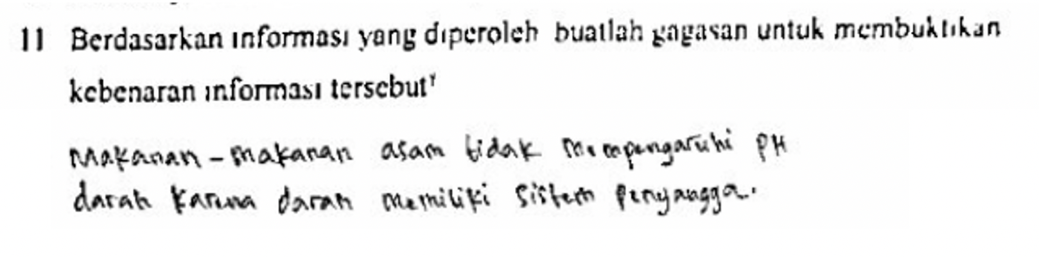
After
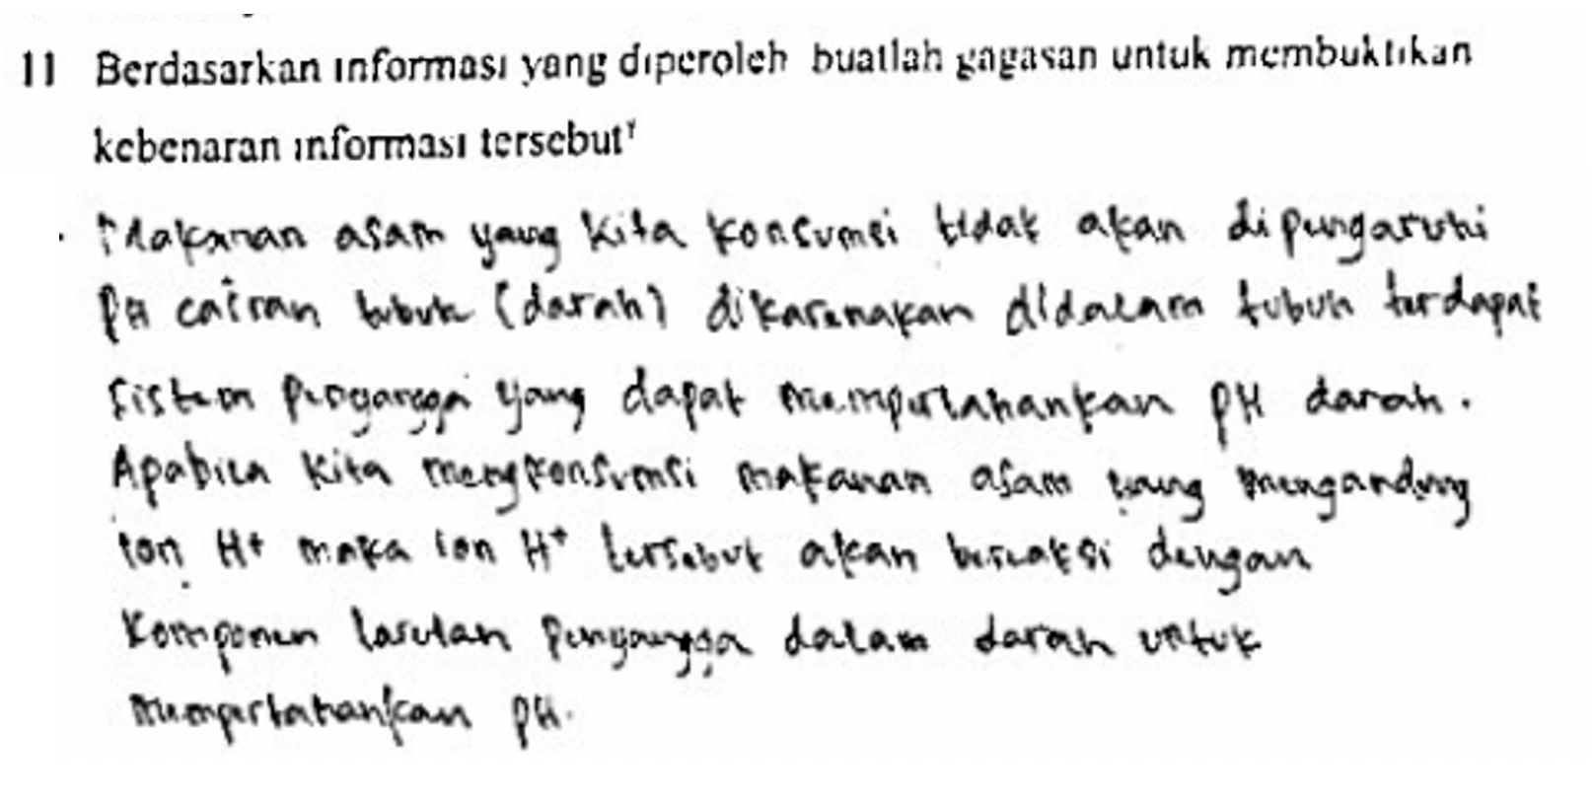
Figure 7. Inference Skills Before and After Guidance

In addition to a significant increase in the average score of post-test and n-gain of critical thinking skills of moderately categorized students in the experimental class, the relatively high Post-test score is also supported by student activity data. The activities of the students who are suspended are activities during the teaching and learning process. The average score of student activity on each activity assessment criterion applied in the inquiry lesson model can be seen in Figure 8.

Activity tasks
Information:
A : Showing enthusiasm
B : Many Ask Questions
C : Expressing An Opinion
D : Giving a Rebuttal
E : Honest
F : Discipline
G : Cooperation
H : Responsible

Figure 8. Average student activity score on each task

Based on Figure 8, it can be seen that the highest average student activity score is found in tasks B and G, which is asking a lot and collaborating. While the lowest average score is found in task H.

CONCLUSION

Based on the results of calculations and discussions, it can be concluded that the inquiry lesson model is effective in improving students' critical thinking skills. It can be seen from the percentage of the average n-gain of critical thinking skills of students in the moderate category experimental class, as well as the average score of critical thinking skills in the experimental class is greater than that of the control class.

REFERENCES
Bell, D., & Kahrhoff, J. (2006). Active Learning Handbook. Louis, Missouri: Copyright Webster University.
Aiman, U., Hasyda, S., & Uslan. (2020). The influence of process oriented guided inquiry learning (POGIL) model assisted by realia media to improve scientific literacy and critical thinking skills of primary school students. European Journal of Educational Research, 9(4). https://doi.org/10.12973/EU-JER.9.4.1635

Costa, A. L. (1985). Developing Minds: A Resource Book for Teaching Thinking. Alexandria: Association for Supervision and Curriculum Development. D.C : NEA

Elisanti, E., Sajidan, S., & Prayitno, B. A. (2018). The Effectiveness Of Inquiry Lesson-Based Immunity System Module To Empower The Students' Critical Thinking Skill. Edusains, 10(1). https://doi.org/10.15408/es.v10i1.7259

Ennis, R. H. (1996). The nature of critical thinking: An outline of critical thinking dispositions and abilities. Presentation at the Sixth International Conference on Thinking at MIT, Cambridge, MA, July, 1994. Faculty.Education.Illinois.Edu.

Fijar, N. A., Saptono, S., & Masturi, M. (2019). Implementation of Guided Inquiry Learning To Improve The Critical Thinking Skills of Junior High School Students. Journal of Innovative Science Education, 8(3).

Fraenkel, J. R., N. E. Wallen., & H. H. Hyun. (2012). How To Design and Evaluate Research In Education Eighth Edition. New York: The McGraw-Hill Companies.

Friedel, C, Irani,T, Rudd, Gallo, M, Eckhardt, E, & Ricketts, J. (2008). Overtly Teaching Critical Thinking and Inquiry-Based Learning: A Comparison Of Two Undergraduate Biotechnology Classes. Journal of Agricultural Education Volume 49, Number 1, pp. 72 – 84.

Hamalik, Oeman. (2005). Curriculum and Learning, Jakarta : Bumi Aksara.

Hasan, R., Lukitasari, M., Utami, S., & Anizar, A. (2019). The activeness, critical, and creative thinking skills of students in the Lesson Study-based inquiry and cooperative learning. Indonesian Journal of Biology Education, 5(1). https://doi.org/10.22219/jpbi.v5i1.7328

Jauhariningsih, R. (2017). Efforts to Improve Learning Outcomes of Acid and Base Chemistry By Using Inquiry Based Learning (Ibl) in Class Xi Ipa 2 Sma Negeri 5 Makassar. Journal of Educational Reason Volume 5, Number 2.

Mahardini, T., Khaerunisa, F., Wijayanti, I. W., & Salimi, M. (2019). Research Based Learning (Rbl) To Improve Critical Thinking Skills. Social, Humanities, and Educational Studies (SHEs): Conference Series, 1(2). https://doi.org/10.20961/shes.v1i2.26816

Maknun, J. (2020). Implementation of Guided Inquiry Learning Model to Improve Understanding Physics Concepts and Critical Thinking Skills of Vocational High School Students. International Education Studies, 13(6). https://doi.org/10.5539/ies.v13n6p117

Marjan, J., I. Arnyana, I. Setiawan. (2014). The Influence of Learning a Scientific Approach on Biology Learning Outcomes and Science Process Skills of Ma Mu'alimat NW Pancor Selong Students, East Lombok Regency, West Nusa Tenggara. E-Journal of Ganesha University Graduate Program. 4(1). 1-12.

Mulyasa. (2010). Education Unit Level Curriculum (KTSP). Bandung: PT Remaja Rosdakarya.

National Education Association . (2012). Audiovisual Instruction Department, New Media and College Teaching. Washington.

Nurdiansyah, S., Sundayana, R., & Sritresna, T. (2021). Mathematical Critical Thinking Ability and Habits Of Mind Using Inquiry Learning Model and Creative Problem Solving Model. Mosharafa: Journal of Mathematics Education, 10(1). https://doi.org/10.31980/mosharafa.v10i1.861

Rusmansyah, Yuanita, L., Ibrahim, M., Isnawati, & Prahani, B. K. (2019). Innovative chemistry learning model: Improving the critical thinking skill and self-efficacy of pre-service chemistry teachers. Journal of Technology and Science Education, 9(1). https://doi.org/10.3926/jotse.555

Sari, A N, Kadaritna, N, & Tania,L. (2013). Learning a Scientific Approach in Improving Students' Original Thinking Skills in Acid-Base Materials. Journal of Chemistry Education and Learning Vol 3, No 2

Sari, R. M., Sumarmi, Astina, I. K., Utomo, D. H., & Ridhwan. (2021). Increasing Students Critical Thinking Skills and Learning Motivation Using Inquiry Mind Map. International Journal of Emerging Technologies in Learning, 16(3). https://doi.org/10.3991/ijet.v16i03.16515

Sund, R. B. & L. W. Trowbridge. (1973). Teaching Science by Inquiry in the Secondary High School. Second Edition. Columbus: Charles E. Merrill Publishing Company.

Susilowati, S, Sajidan, S, & Ramli, M. (2018). The effectiveness of inquiry lesson-based learning tools to improve students' critical thinking skills. Journal of Educational Research and Evaluation Volume 22, No 1, June 2018 (49-60)

Sutiani, A., Situmorang, M., & Silalahi, A. (2021). Implementation of an Inquiry Learning Model with Science Literacy to Improve Student Critical Thinking Skills. International Journal of Instruction, 14(2). https://doi.org/10.29333/iji.2021.1428a

Trisdiono, H., Siswandari, S., Suryani, N., & Joyoatmojo, S. (2019). Multidisciplinary integrated project-based learning to improve critical thinking skills and collaboration. International Journal of Learning, Teaching and Educational Research, 18(1). https://doi.org/10.26803/ijlter.18.1.2

Utomo, N.P. (2018). Development of Inquiry Lesson-Based Modules To Improve Science Literacy Process Dimensions And Learning Outcomes Skill Competencies In Digestive System Material Class XI. BIOSPHERE Journal of Tadris Biology Education Vol. 9 no.1 (2018) 45-60

Wale, B. D., & Bishaw, K. S. (2020). Effects of using inquiry-based learning on EFL students' critical thinking skills. Asian-Pacific Journal of Second and Foreign Language Education, 5(1). https://doi.org/10.1186/s40862-020-00090-2

Wenning, Carl J. (2010). Levels of Inquiry: Using inquiry spectrum learning sequences to teach science. Journal Physics Teacher of Education Online. 5, (4). 11-19

Zulaichah, S., Sukarmin, S., & Masykuri, M. (2021). Development of Science Modules Based on Inquiry Lessons on Business Materials and Simple Aircraft to Increase Students' Scientific Creativity. Edusains, 13(1). https://doi.org/10.15408/es.v13i1.17389

