MEANING IN THE ANIMATED CHILDREN’S MOVIE
“RABBIDS INVASION”

Kuntayuni
Universitas Warmadewa
kuntayuni@warmadewa.ac.id

Agus Darma Yoga Pratama
Universitas Warmadewa
agusdarmayoga85@yahoo.com

Abstract
Audiovisual research is not only limited to an analysis of the translation applied to movies, but also about the meaning and how the aspects of that meaning can be well understood by the audience. The meaning of the movie refers to the verbal meaning and nonverbal meaning to see how the meaning of the movie is conveyed to the audience as a whole because verbal and nonverbal language basically has its own uniqueness in the process of conveying meaning. This study also aims to analyze the storyline to obtain the unity of verbal and nonverbal meanings in building the overall story in the movie. The research data chosen was the animated children’s movie “Rabbids Invansion” because it contains nonverbal signs which tend to be more than verbal language. Although there is verbal language, what appears refers to verbal language that is unknown or difficult to understand the meaning directly. The power of imagination in movie “Rabbids Invansion” is very strong. Therefore, the study of meaning in this movie becomes a very interesting and need to be analyzed in details. This research begins by listening to the movie, followed by collection data through screen recording techniques for data collection of visual or image aspects and taking a note for verbal language. The results of this study could later be useful for audiovisual researchers in producing a study in the field of meaning of children’s animated movie.

Keywords: meaning, movie, image, verbal, nonverbal, plot.

Abstrak
Penelitian audiovisual bukan hanya sebatas analisis tentang terjemahan yang diterapkan pada film, tetapi juga mengenai makna serta bagaimana aspek makna tersebut dapat dipahami dengan baik oleh penonton. Makna pada film merujuk pada makna verbal dan makna nonverbal untuk melihat bagaimana penyampaian makna dalam sebuah film kepada penonton secara utuh karena pada dasarnya bahasa verbal dan nonverbal memiliki keunikan tersendiri dalam proses penyampaian makna. Kajian ini juga bertujuan untuk menganalisis alur cerita guna mendapatkan kesatuan makna verbal dan nonverbal dalam membangun cerita secara keseluruhan pada film. Adapun data penelitian yang dipilih yakni film animasi anak “Rabbids Invansion” karena film ini mengandung tanda-tanda nonverbal yang cenderung lebih banyak daripada bahasa verbal. Meskipun ada bahasa verbal, namun yang muncul merujuk pada bahasa verbal yang sulit dipahami makna atau artinya. Daya imajinasi pada film animasi “Rabbids Invansion” sangat kuat sehingga kajian makna pada film ini menjadi suatu hal yang sangat menarik dan perlu dianalisis lebih mendalam. Penelitian ini diawali dengan menyimak film tersebut yang dilanjutkan dengan pengumpulan data melalui teknik rekam layar untuk pengumpulan data aspek visual atau gambar dan teknik simak catat untuk data bahasa verbal. Hasil penelitian ini nantinya dapat berguna bagi para peneliti audiovisual (film) dalam menghasilkan sebuah kajian pada bidang makna khususnya pada film animasi anak.

Kata Kunci: makna, film, gambar, verbal, nonverbal, alur.

INTRODUCTION
When humans interact with others that they do not share the same linguistic codes with, it is the nonverbal communication they rely on to make them get along. The final of nonverbal communication is taking account into nonverbal meaning. Nonverbal meaning may be said to be a universal property of humans, though, with slight variations in some cultures specific cues (gestural, facial etc.) (Ekman & Keltner, 1997). The meaning that is sent and received through “visual, vocal, tactile, olfactory, gustatory, chronemics, and artifactual behaviours” (Guerrero & Floyd, 2006). Nonverbal meaning is received through more sense organs – touch, taste, seeing, hearing, smells, signs, symbols, colours, facial expressions, gestures, posture, and intuition (Calero, 2005). Nonverbal meaning may be seen to carry more interpretation than verbal meaning due the different modes at its disposal. Nonverbal has all the senses as the modes of expression of verbal meaning. Verbal meaning comes from vocal or nonvocal (speech and writing) modes. Verbal meaning refers to the meaning contained in the words, phrases, or sentences (Kurniati, 2016).
Baker (2001) stated that audio visual covers four semiotic channels, they are verbal auditory (speech and dialog), nonverbal auditory channel (music and sound effect), verbal visual channel (subtitle and written sign), and non-verbal visual channel (picture composition and flow). However, in children’s animated movie “Rabbids Invansion” does not covers all four semiotic channels, there are only two channels: non-verbal auditory (music and sound effect) and non-verbal visual (picture composition and flow), even though sometimes there are some expressions like screaming and laughing or unknown words “ta-ta-ta” and “ba-ba-ba” that must be considered the meaning by its context. Nonverbal aspects are all forms of signs that are not words. There are various nonverbal signs in this film, namely images, facial expressions, audio, gestures, and colors (Kress and Leeuwen, 2002). Images refer to the objects that are visually visible, both moving and immovable. Facial expressions mean the emotions of the good characters, happy, sad, angry, and disappointed. Audio is about the sound effects of characters as well as music and songs. Gesture refers to body movements, head movements, eye contact, eye gaze, mouth movements, and others. Wide open eyes indicate a willingness to accept a response to a signal, clenched teeth mean anger, then happy expression can be seen when the mouth is wide open, the cheeks are red, and the eyes are narrowed (Herlina, 2010). The color of the objects around the character.
There are various researches which discuss about the verbal and nonverbal meanings the movie, but the number of research that focuses on analyzing the meanings (verbal and nonverbal) on children’s animated movie is still quite a bit. Rusmana, et al (2020) in their research “The Meaning of Nonverbal Messages in Cartoon Larva Season 3 Episodes Garlic 1 and 2” discussed about the nonverbal meaning in the children’s silent animation entitled Larva especially season 3 episodes Garlic 1 and 2. The result of their research was the meanings of nonverbal messages displayed in Larva season 3 episode Garlic 1 and 2 also reflected in recent life issues such as struggling, respecting others, earnest, and being patient. Hasbullah and Yasa (2020) in their research “Verbal Signs in The Animation Film El Empleo”. The focus of their research was to analyze in depth in the first, middle, and end scenes of verbal signs also the intent that the animator communicates in the animated film. The result of their research showed that at the level of verbal signs in the first, middle, and final scenes, they can be divided into: icons depicting a man living as a boss; humans as subordinates are symbolized as seats, vehicles, traffic signs, even as footwear in front of the toilet door, index looks at the boss's facial expression, and subordinates that indicate oppression. However, in this research, it is explored the meaning of verbal and nonverbal, multimodality aspects, also the storyline (plot) of children’s animated movie which is very unique, namely ‘Rabbids Invansion’. This movie is constructed with verbal and nonverbal meaning. Verbal meaning which mostly come from unknown language like “ta-ta-ta-ta”; “ba-ba-ba-ba”, and many more. Meanwhile, nonverbal meaning is obtained from the presence of image, color, and many more. With the existence of nonverbal meaning which is more dominant than verbal meaning can cause the difficulty in interpreting the value of the story. Therefore, this research also explores about the plot of the story in the movie ‘Rabbids Invansion’. The focus of this research is more comprehensive than the previous research.

THEORETICAL BASIS
There are several theories used in analyzing the data. In order to analyze the unknown verbal concept and the meaning of nonverbal signs, the theory of Kress and Leeuwen (2006) is used as well as the theory of Anstey and Bull (2010), while to analyze the delivery of the storyline in the movie, the theory of Waluyo is used (2002).

Verbal and Nonverbal Meanings
Verbal and nonverbal meanings refer to the function of the text as multimodal. In this case, verbal and nonverbal signs are combined into a semiotic system that contains a meaning or purpose which can then be interpreted. According to Kress and Leewen (2006), verbal meaning is obtained from verbal signs in the form of speech and writing, while nonverbal meaning comes from the presence of nonverbal signs referring to images, cues, movements and interactions with objects, and colors. Anstey and Bull (2010) add that verbal signs containing verbal meaning can be seen from the vocabulary of the word. Meanwhile, nonverbal meaning can be interpreted through nonverbal signs, namely the tone and rhythm of music and sound effects, facial expressions, body movements, such as how to sit, hear, see, move, stand and hold your head which can produce the impression of paying attention to something or not being interested. and confusion. Then through touches such as a handshake, patting the shoulder, stroking hair, hugging which gives a close and intimate meaning.

Plot
The story line or plot serves to provide a detailed understanding of the story and provides certain stages for the author to continue the story to the next stage. According to Waluyo (2002), the plot is also related to the division of time and the rhythm of the story. At the beginning of the story, the rhythm of the time is quite loose. The time to tell the story is getting faster on the complexity side and even faster on the gauging so that it quickly becomes a climax. The storyline includes seven elements, namely:

- Exposure means explaining the beginning of the story. The author begins to introduce the place, time, topic, and characters. Characters as actors in the story. There is also a place where an event occurs. While time refers to the adverb of the time when the story occurs. Likewise with the atmosphere in the story.
- Stimulation is an event that the emergence of problems that are displayed by the author for further development. At this stage, the author tries to present an event that ignites so that it attracts the attention of the reader.
- Surveillance is about the increase in conflict. The problems that have been raised in the previous stage are increasingly being developed in terms of intensity. These events make the story even more interesting.
- Complications refers to getting more difficult. Dramatic events that become the core of the story are getting more and more tense. Conflicts that occur, internal or external, lead to a climax that is difficult to avoid.
- Climax is very important in the plot structure. The climax determines how the problem will be solved. A conflict becomes a climax because it is influenced by the attitude, will, and the main goal of the author in building a conflict according to the demands and coherence of the story.
- Dissolution as the final stage in the story. At this stage, certain scenes will be shown as a result of the climax.
- Completion refers to the final stage in a story. This section contains how the ending of a story.

METHODS
This research refers to descriptive qualitative research which aims to understand the phenomena experienced by research subjects, for example behavior, perceptions, motivations, actions, and others that are holistically and descriptively in the form of words and language in a context. specifically natural and by utilizing various natural methods (Moeleong, 2011). In this research, there are several stages carried out, namely data collection methods, data analysis methods, and presentation or data analysis.
Researcher made direct observations of the object of research by listening and observing unknown verbal concept, nonverbal aspects, as well as the story line of each scene in the children’s animated movie “Rabbids Invansion”, especially on episodes: The Best Fails, The Best Dances and Songs, The Saddest Moment, The Scariest Moment, The Best Sneak Peak, and The Last Rabbit. These episodes were chosen due to various scenes coloring with unique nonverbal signs and powerful imagination. The data were then documented through screenshot technique. The collected data were analyzed by first grouping the data according to the theory used, namely the unknown verbal meaning and nonverbal meaning found in the movie along with the explanation, followed by an analysis of the delivery of the storyline in the movie “Rabbids Invansion”.
Presentation of data analysis in this research can be divided into two, namely formal methods (pictures) and informal methods (words or descriptions). Sudaryanto (1993) also emphasizes that the presentation of the data can make it easier for readers to understand the research results and of course it is very interesting to display the combination of the two formal and informal methods.

RESULTS AND DISCUSSION
In movies, the meaning or message conveyed to the audience must be well understood (Pratama, 2015). Therefore, the verbal and nonverbal aspects are two very important aspects to be considered in this research. The verbal aspect refers to all types of symbols that use one or more words. Verbal aspects explain messages by utilizing words (language) both orally and in writing. Meanwhile, nonverbal aspects are all forms of cues that are not conveyed through verbal message words. Nonverbal aspects are symbols or symbols that do not use words, such as gestures, expressions, music and others. Verbal and nonverbal aspects in conveying meaning can be found in various movies, one of which is children’s animated films.
An animated children’s movie certainly has a unique process of conveying meaning. It accommodates all the power of human imagination and creativity in it. There are various examples of animated children’s movies such as “Rabbids Invasion”. It is an animated movie that tells about the ridiculousness of a group of extraterrestrial beings shaped like rabbits who are trying to rule the earth. The Rabbids in the form of a white rabbit have a very curious nature and want to know various things. They spend their time on earth adventuring and trying things in their own way. The silliness that they do often brings them into funny situations. “Rabbids Invansion” is a French animated television series that premiered on August 3, 2013. The series is a co-production with Ubisoft Motion Pictures, Team TO, and CNC. The show is based on the Raving Rabbids video game series produced by Ubisoft. The message or meaning behind the show and the creation of characters including words, sounds, colors, shapes, gestures, gestures and others can indicate the relationship between French culture and the creation of the movie “Rabbids Invansion”. The following describes the unknown verbal concept and nonverbal meanings in the “Rabbids Invasion” movie.

Unknown Verbal Concept in Rabbids Invasion
Verbal meaning is a meaning that comes from the mouth of the actors or actresses as well as the writing that is contained or appears in the movie, for example, dialogue in the movie (Pratama, 2015). “Rabbids Invansion” tells about the ridiculousness of a group of extraterrestrial beings shaped like rabbits. The silliness is expressed through the unknown words they say orally. Therefore, in this research also analyzed the meaning or information about the ridiculousness of the rabbids that can be conveyed verbally by analyzing based on the context. The verbal meaning found the most was the meaning that shows the expression of the rabbids’ feelings for everything experienced in this movie. There were six types (30%) of the twenty meanings. The description of the verbal meaning in the Rabbids Invasion movie is as follows.

- Minute 0:04
A rabbit appeared suddenly with a standing position around the desert overgrown with cactus plants. The rabbit said “ta-ta-ta-ta”. These words are included in the category of language that is not recognized or cannot be directly understood. However, the meaning or purpose of the word “ta-ta-ta-ta” can be interpreted by paying attention to the visual mode through facial expressions and even body movements of the rabbit. When the rabbit said “ta- ta-ta-ta”, the rabbit’s facial muscles can be seen pulling the corner of the mouth up and showing a row of teeth, his eyes were so bright and wide, his left hand was down, and his right hand was up while holding the key. This shows that the rabbit is very happy and excited. The movement of his hand as a form of welcome or a warm greeting from him because he will meet his friend.
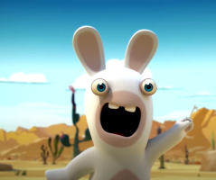

- Minute 0:17-0:19
In the desert, when the rabbit would like to hug her friend (doe), suddenly a truck appears with a hanging magnet. The truck was moving very fast so when the doe crossed the road to meet the male rabbit, her body was suddenly blown away by the truck with the magnet. She was not only blown away but also pulled by a magnet until the truck finally carried her away. When the doe went far away, carried by the truck, the male rabbit was very sad, where he just fell silent without a smile and his gaze was lethargic. The rabbit said “oh papa”. The facial expression and the expression “oh papa” conveyed by the rabbit indicated that the rabbit was in a very disappointed condition because he failed to meet his friend.

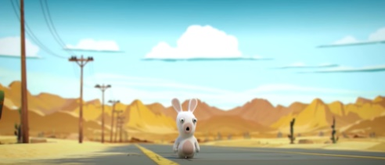

- Minute 0:15
Not being able to meet his friend, the rabbit went to a park surrounded by colorful trees. He walked alone. There was no one to accompany him. He wept with tears in his eyes as he shouted, his mouth wide open, devoid of passion and passion. He then raised his hands and said “pa-pa-pa”. The words “pa-pa-pa” verbally include language that cannot be understood directly. Thus, the presence of visual modes such as facial expressions and body movements of the rabbit helps in interpreting the meaning of the verbal expression “pa-pa-pa”. By knowing the rabbit's facial expressions and body movements, it can be concluded that the meaning of the phrase “pa-pa-pa” as a feeling of sadness is very deep because he cannot meet and play with his friends anymore. No friends accompany him anymore. His mood is very sad and disappointed.
As explained earlier that the rabbit was in a park surrounded by colorful trees. There were brown, green, and turquoise trees. Green and turquoise colors symbolize a state of peace and calm. While the brown color indicates support and a sense of comfort. But this condition is exactly the opposite of what the rabbit felt. He was so sad and disappointed because he felt alone and lonely, none of his friends met, accompanied, provided support, even invited him to play. He felt uncomfortable with the loneliness he faced.

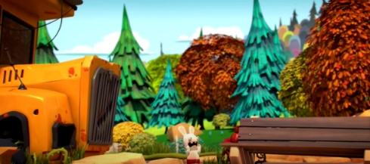

- Minute 1:53
One night with a sprinkling of bright stars lighting up the beautiful night and blue and green pine trees. At that time, there was a rabbit standing wearing a yellow hat while looking up at the sky full of starlight. A few minutes later, he saw the appearance of a space object, namely a UFO. The UFO then emitted light. When the UFO emitted light, the rabbit’s eyes and mouth opened wide and his eyebrows shot up. He also said the word “wow”. This shows that he was surprised and so surprised to see celestial objects directly.

- Minute 1:18
Rabbit with his friends were somewhere. There was a red-green dinosaur. His body size was so big like a giant. The dinosaur’s teeth were large and long. He also had hair on his head. His hair was like thorns. With the physical appearance of the dinosaur as if it was ugly, the rabbits laughed and ridiculed the dinosaur while saying “ta-ta-ta-ta-ta-ta”. The word “ta-ta-ta-ta-ta-ta” is included in the category of language that is not recognized, because its meaning or meaning cannot be simply understood. However, with the appearance of the visual mode, namely the physical characteristics of the dinosaurs, facial expressions and body movements of the rabbit, it can be concluded that the expression “ta-ta-ta-ta-ta-ta” seems to be a form of mockery or ridicule by the rabbit towards the dinosaur.

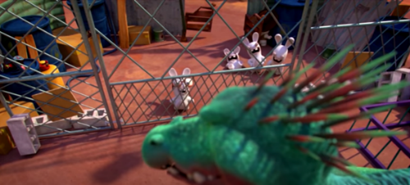

- Minute 0:30
A rabbit wearing a cheap young dress was standing on top of the car while smiling broadly and saying “bye-bye”. These well-known words show that she is very happy that she can manage to escape from the people who wanted to catch her because her silliness.

Non-Verbal Meaning in “Rabbids Invasion”
Nonverbal meaning refers to the meaning obtained from all forms of cues that are not conveyed through words, but through pictures, body movements, facial expressions, body postures, tactile behavior, and others. “Rabbids Invansion” tells about the ridiculousness of a group of extraterrestrial beings shaped like rabbits. They have a great curiosity about something. What they do and feel are presented through nonverbal elements. The nonverbal meanings found the most are the meanings of each action or behavior performed by the rabbit. The meaning of the action or behavior found as many as fourteen types (70%) of the twenty meanings contained in the movie. The description of nonverbal meaning in the “Rabbids Invasion” movie is as follows.

- Minute 0:06
A rabbit with a small pink circle on the forehead accompanied by fur next to its ears with wide eyes, wide open mouth, and both hands raised up. The small pink circle on the forehead indicates that the rabbit is a female rabbit. The color pink is synonymous with femininity (things related to the gender of ‘female’ in the human context and gender ‘female’ in the context of animals. This is also reinforced by the rabbit’s physical characteristics, namely having feathers next to its ears. The feathers seemed to symbolize the rabbit's thick hair. The mouth was wide open while both hands were raised up indicating that the female rabbit was very enthusiastic because she wanted to meet her friend.

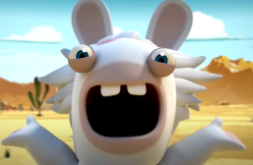

- Minute 0:08
A male rabbit who had brought the key ran slowly to meet his friend (a female rabbit - doe) who was across the road in the desert area. Vice versa, the doe ran slowly to immediately meet the male rabbit. They were very happy while laughing out loud. This shows how happy they are to meet each other and play together again.

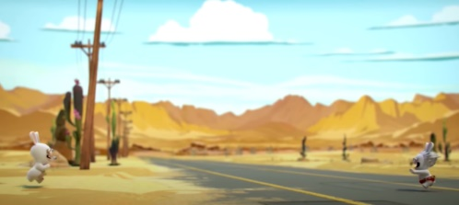

- Minute 0:11
A female rabbit (doe) wearing a red waist bag equipped with a key chain made of iron. The expression on her face was frightened. Her mouth was wide open symbolizing her feelings of being so scared and confused about what to do to save herself. Her hands were raised as if she wanted to ask her friends for help. She was very scared because she was hit by a truck that was accompanied by a hanging magnet that was traveling so fast.

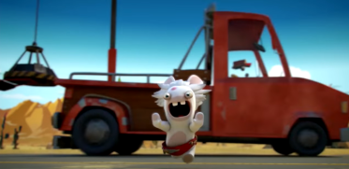
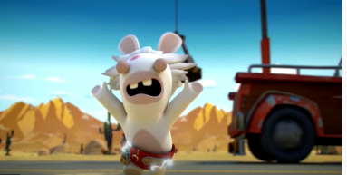
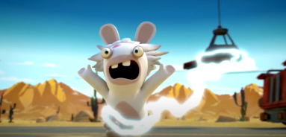

- Minute 0:16
The female rabbit (doe) was attached to the magnet on the truck. She was carried away by a truck that was accompanied by the magnet. The rabbit widened its eyes and pulled its chin down. Her forehead furrowed and her lips were drawn. This facial expression showed that the rabbit was very frightened. She did not know where the truck with the magnet was going to take him. She could not meet his friends.

- Minute 0:06
Three male rabbits and a female rabbit were wearing a pink skirt stand in a circle while looking at the image of a ballet dancer wearing a pink dress against a bright full moon. The atmosphere was so quiet and serene. The rabbit did not say anything. The image of a ballet dancer wearing a pink dress symbolizes the love and warmth that develops between them.

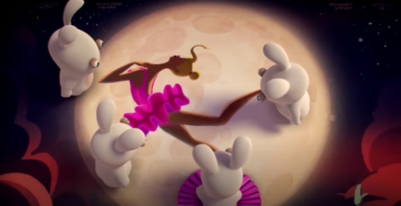

- Minute 0:08
The female rabbit was wearing a pink skirt turned to face the other rabbits while raising her hands. She seemed to want to say something. Her eyes were sharp and serious. The other rabbits are also watching intently.
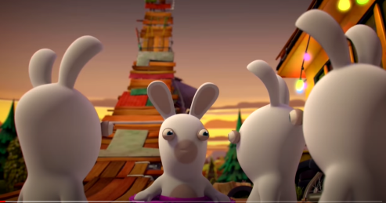

- Minute 0:09 – 0:10
The female rabbit wearing a pink skirt pointed at something up in the sky. So did the other three rabbits. It turned out that what was pointed at was a bright full moon. They were so stunned by the beauty of the full moon.
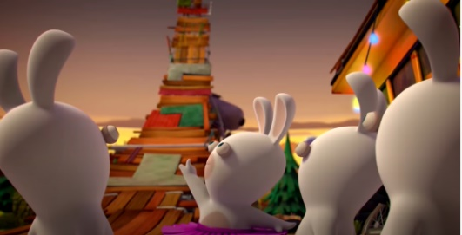

- Minute 0:11
Besides being stunned to see the full moon, the rabbits were also surprised. Their eyebrows rose and eyes widened. The female rabbit also widened her eyes and opened her mouth wide. They all looked at the full moon.

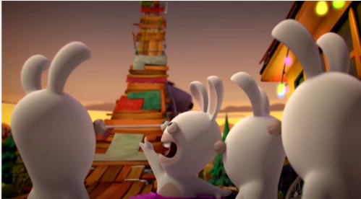

- Minute 0:12
The presence of the full moon makes them prancing rabbits. His eyes widened as he smiled happily. The beauty of the full moon really soothed their hearts and made the atmosphere more cheerful.
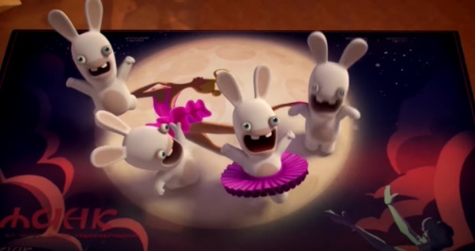

- Minute 0:13
When the three male rabbits pranced with joy at the full moon, suddenly one of the rabbit’s hands hit the female rabbit. There was the sound effect of hands hitting the female rabbit’s body.
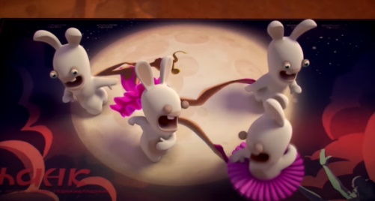

- Minute 0:17
The female rabbit in the pink skirt was blown away and flew into the sky. Her eyes and mouth were closed. Her hands seemed to be dancing. Classical music sounds. The rabbit really enjoyed the atmosphere he was in.
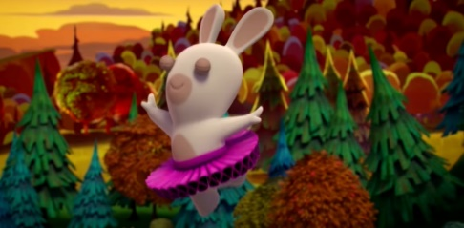

- Minute 0:05-0:06
A rabbit looked so sad. His mouth closed. His eyes drooped. He stood alone in the field. There was a sad moaning voice. He looked at the moon. He seemed to see his friends were joking and laughing together. This shows that he really misses being with his friends. He felt helpless. He felt alone. There is no one to accompany and love him.

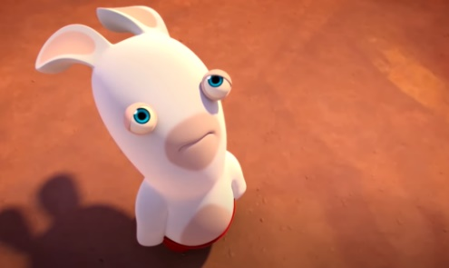
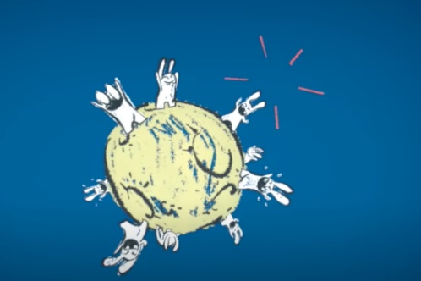

- Minute 3:36
A rabbit is in a garden. Then he heard the sound of a cat. The cat turned out to be in a cardboard box. The rabbit lifted the cat’s body and hugged the cat tightly. He gave a soft touch in the form of a hug to the cat. He welcomed the cat’s presence with a happy smile. He feels like he has found a friend again.

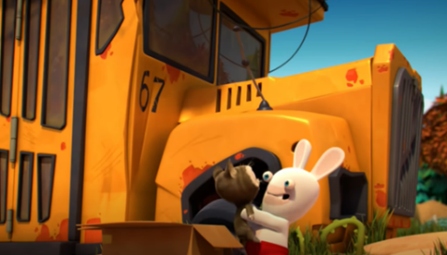

- Minute 3:47
Even though the rabbit welcomed the cat’s presence gently and warmly. But the cat did not like the way the rabbit treated him. Finally, the cat went berserk. He hit the rabbit. Until the rabbit was injured and fell. Rabbit also asked for help from the people around him. But there was no one to help him.

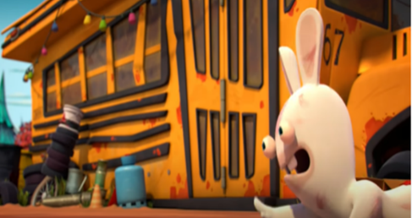

Plot in Rabbids Invansion Movie
In addition to the analysis of unknown verbal concept and nonverbal meanings, this research also aims to determine the delivery of the storyline in the “Rabbids Invansion” movie. The storyline presented can help the audience understand the existence of nonverbal aspects which tend to be more than verbal aspects. The story line is not just a series of events contained in certain topics, but includes several factors that cause events. Plot as a dramatic activity of characters based on the point of view of a number of events that build the story as a whole (Propp, 1968). The exploration of the storyline includes seven elements of the plot, namely exposure, stimulation, initiation, complexity, climax, dissolution, and completion. The description of the delivery of the storyline in the “Rabbids Invasion” movie can be viewed as follows.

- Rabbids Invasion-The Best Fails (total 6.21 minutes)
The exposure was started by the appearance of a male rabbit in a desert overgrown with cactus plants during the day. The rabbit stood alone with his mouth wide open and his eyes wide while holding a key and also said “ta-ta-ta-ta”. The stimulation of the next story was expressed a few minutes later, when a rabbit with a small pink circle (female rabbit) appeared. The female rabbit wanted to meet and even hug the male rabbit soon. The female rabbit was hurry up to cross to come closer to the male rabbit who was in the across the desert. But, suddenly, a truck with hanging magnet was driving so fast then it knocked the female rabbit away and her body was immediately attached to the magnet on the top of the truck. Her body can be attracted to a magnet because she wore a skirt with ornaments made of iron. This was as the surveillance part of the story, wherein the problem was more increasing and making the male rabbit’s condition more difficult to meet with female rabbit. Even the male rabbit kept trying to chase the female rabbit, but it did not work. As the ending of the story, the male rabbit looked very sad and disappointed because he could not help the female rabbit and also he could not meet even play with her. What to do by the male rabbit next was not described clearly in the story.

- Rabbids Invasion-The Best Dances and Songs (total 6.16 minutes)
The exposure of the story could be seen when the a female rabbit with three other male rabbits who stood in the land circularly while looking at a picture of a ballet dancer wearing a pink dress against a bright full moon. Suddenly something happened as the stimulation of the story. The female rabbit who was wearing a pink skirt turned to the other bunny. She looked up as she raised his hands. Then, the female rabbit pointed at something towards the sky as well as the other three rabbits. They pointed to a bright full moon. They were also very surprised but actually they were happy until they were prancing around with joy. But suddenly, a conflict occured and made the situation became more difficult. The surveillance part of this story was when three rabbits pranced around, one of the rabbit’s hand hit inadvertently the female rabbit. Then, the female rabbit in a pink skirt was blown away and flew into the sky. The three rabbits was shocked to see that incident. They would like to help the female rabbit, but they could not. At the end of the story, the female rabbit kept flewing into the sky while dancing beautifully and very gracefully to soothing ballet music. She looked very happy and happy.

- Rabbids Invasion-The Saddest Moment (total 2.49 minutes)
The exposure of this story was started with a rabbit standing alone in a field at night where the moon was shining brightly. Then the stimulation part of this story can be seen when he suddenly remembered his togetherness with his friends. This condition then became a deep conflict (surveillance) when the rabbit as if to see his friends were joking and laughing together in the bright moon. He then became crying. His mouth was tightly shut and trembling. His voice moaned pitifully. This made him even more sad, disappointed, and lonely. There was no one friend to meet him, ask him to play, or just have fun together. There was not clear ending of this part of the story, whether the rabbit kept crying and sad or he did other things.

- Rabbids Invasion-The Scariest Moment (total 5.29 minutes)
This story was started in the afternoon when the rabbit and his friends were at the zoo. Then continued with the stimulation of the story when they saw a dinosaur that was being locked up in a cage with iron fence. The dinosaur was ugly and very big in green with reddish stripes. The physical appearance of dinosaur made the rabbit and his friends laughed out loud while saying “ta-ta-ta-ta-ta-ta”. They mocked the dinosaur not just by saying but also by thrusting their ass. This became a big conflict (surveillance) between the rabbits and dinosaur. Bad attitude of the rabbits who were mocking then made the dinosaur was very angry and annoyed. The dinosaur then broke the iron cage. He also managed to break it down and soon he was trying to hurt the rabbits. The rabbits were scared and tried to run away. At the end of this story, it could not be known whether the rabbits were successfully caught or even they died.

- Rabbid Invasion-The Best Sneak Peak (total 1:02 minutes)
The exposure of this story was begun with people who would like to catch the rabbit who has caused the chaos in the street. Then the stimulation part of this story was conveyed when the rabbit tried to run as fast as he could until he slipped somewhere in the street. The people had found him, but the rabbit kept running away. Finally, they arrived at the highway. They saw a car overturned in the street. At the same time, they saw the rabbit who smiled and said “bye-bye”. This saying became the surveillance of the stroy since the people were more annoyed because the rabbit said that and attempted to escape. The rabbit did not care with those people even they ask the rabbit to come closer. The rabbit still refused to be caught until she ran away again. Those people were more annoyed and angry then they decided to chase the rabbit. The ending of this story was not clear described, whether the rabbit was successfully caught and punished, the rabbit died, or even the rabbit successfully escaped from those people.

- Rabbid Invasion-The Last Rabbit (total minutes)
The exposure of this story was begun with the presence of a rabbit in the afternoon, especially in the garden with colorful and beautiful plants. He felt lonely because there were no friends who accompanied him to play. As the stimulation part of this story, the rabbit suddenly heard the sound of the cat in a small box beside the trash can. The rabbit was surprised that there was a cat in the box. The cat was also surprised to see the rabbit. However, their meeting was being a conflict (surveillance of the story) when the rabbit picked the cat up and immediately hugged him very tightly but suddenly the cat refused the rabbit’s action. He did not like being hugged. He was so upset until he pushed the rabbit down and really hurt him. Rabbit then tried to ask for help from the people around. But there was no one to help him. As the ending of the story, it was not explained that rabbit was still hurt until died or rabbit went away from the cat.

CONCLUSION
Based on the description of the discussion above, it can be concluded that the “Rabbids Invansion” movie contains as one of the most unique children’s animated movies in terms of conveying meaning and the storyline. Among four semiotic channels in audiovisual (movie), it only has two semiotic channels, they are non-verbal auditory (music and sound effect) and non-verbal visual (picture composition and flow), even though sometimes there are some expressions like screaming and laughing or unknown words “ta-ta-ta” and “ba-ba-ba” that must be considered the meaning by its context. Meanwhile, nonverbal meanings comes from picture, gestural, color, and sound effect. From six episodes of “Rabbids Invansion”, it can be found that the storylines only have three elements among six elements of plot, namely exposure, stimulation, and surveillance as these episodes are categorized into a short movie (about 2-6 minutes). The exposure in six episodes of “Rabbids Invansion” are dominantly started with the presence of one or more rabbits accompanied by silly, adorable, or even sad behavior when morning, afternoon, and night in the street, park, and land. The stimulations of this movie are very diverse like attaching to the magnet on the top of the truck, pointing to a bright full moon at night, remembering the togetherness with friends, seeing big dinosaur with ugly face, running away from the people, and also hearing the sound of the cat in the box. Meanwhile, the surveillance of the stories in this movie can be seen from the rabbits’ actions when trying to chase the female rabbit who had been attached in the hanging magnet of the truck, hitting inadvertently the female rabbit, imagining his friends were joking and laughing together in the bright moon, mocking the dinosaur, making fun of people, and hugging the cat tightly. The stories in six episodes of this movie become more interesting due to the variety of events and conflicts that happen in the rabbits such as disappointment and loneliness without friends, being chased by huge dinosaurs, success in escaping from people, and more. “Rabbids Invansion” is colored with strong imagination, unique due to unknown language, incomplete storylines, and silliness of the characters. In this movie, the viewers do not know the end of story and it is still becoming mystery whether the rabbids happy, sad, still alive or dead as the impacts of conflicts

REFERENCES
Anstey, M. & Bull, G. (2010). Evolving Pedagogies: Reading and writing in a multimodal world, Education Services Australia Limited, Sydney, Australia.
Badan Pengembangan dan Pembinaan Bahasa. (2021). Kamus Besar Bahasa Indonesia. Diakses tanggal 10 September 2021 dari https://kbbi.kemdikbud.go.id/
Baker,M.,ed., (2001). Routledge Encyclopedia of Translation Studies. London: Routledge Taylor and Francis Group.
Baker, M. (2018). In Other Words: A Coursebook on Translation. New York, NY: Routledge.
Cintas, J. D., RamaeL, A. 2007. Audiovisual Translation: Subtitling. Manchester: St. Jerome
Publishing.
Calero, H. H. (2005). The power of nonverbal communication: How you act is more important than what you say (1st ed.). Los Angeles: Silver Lake Publishing.
Ekman, P. (1957). A methodological discussion of nonverbal behaviour. The Journal of Psychology, 43, 141 – 149.
González, L. P. (2014). Audiovisual Translation Theories, Methods and Issues. London: Routledge
Taylor and Francis Group.
Guerrero, Laura K. & Floyd, K. (2006). Nonverbal communication in close relationships.New Jersey: Lawrence Erlbaum Associates.
Heri. (2017). 13 Arti Warna dan Psikologi Warna. Diakses pada 9 September 2021 dari https://salamadian.com/arti-warna/
Herlina. (2010). Isyarat Wajah. Bandung: Universitas Pendidikan Indonesia.
Hasbullah., Yasa, N. M. (2020). Verbal Sign in Animated Movie ‘El Empleo’. Journal of Nawala Visual. Vol. 2 (1).
Kurniati, D. P. Y. (2016). Modul Komunikasi Verbal dan Non Verbal. Denpasar: Universitas Udayana.
Kress, G. & Van Leeuwen, T. 2002. Colour as A Semiotic Mode: Notes for A Grammar of Colour. Visual Communication, 1-27.
Kress, G. & Van Leeuwen, T. (2006). Reading Images: A Grammar of Visual Design. Accessed on 9th September 2021 from https://www.researchgate.net/publication/276935749_Reading_Images_A_Grammar_of_Visual_Design
Moleong, L.J. (2011). Metodologi Penelitian Kualitatif Edisi Revisi. Bandung: PT. Remaja Rosdakarya.
Putra. 2020. Macam dan Jenis Emosi yang Ada Dalam Diri Manusia. Diakses pada 9 September 2021 dari https://today.line.me/id/v2/article/NkwL68
Puji. 2018. Menguak 7 Tipe dan Arti Senyuman yang Mungkin Pernah Anda Lakukan. Diakses pada 9 September 2021 dari https://hellosehat.com/mental/gangguan-mood/tipe-dan-arti-senyuman/
Propp, V. 1968. Morphology of the Folktale. Amerika: Martino Publishing. Accessed on 9th September 2021 from https://monoskop.org/images/f/f3/Propp_Vladim
ir_Morphology_of_the_Folktale_2nd_ed.pdf
Pratama, A. D. Y. 2015. Aspek Legibilitas Dalam Penerjemahan Teks Alih Bahasa. Jurnal Ilmu Bahasa, Vol. 1 (1). Page. 137-154.
Rusmana, D. R. A., Jupriono., Meidyastuti, R. T. (2020). The Meaning of Nonverbal Messages in Cartoon Larva Season 3 Episodes Garlic 1 and 2. Journal of Representamen, Vol. 6 (1). Retrieved at 8th September 2021 from http://jurnal.untag-sby.ac.id/index.php/representamen/article/view/90-105
Rabbids Invansion - The Best Fails. Accessed on 8th September 2021 from https://www.youtube.com/watch?v=qMNc6ugqAAg&t=4s&ab_channel=RabbidsInvasion
Rabbids Invasion – The Best Dances and Songs. Accessed on 8th September 2021 https://www.youtube.com/watch?v=Quj2CRErVko&t=56s&ab_channel=RabbidsInvasion
Rabbids Invasion – The Saddest Moment. Accessed on 8th September 2021 from https://www.youtube.com/watch?v=kPWq0fDkwKc&t=15s&ab_channel=RabbidsInvasion
Rabbids Invasion – The Scariest Moment. Accessed on 8th September 2021 from https://www.youtube.com/watch?v=tXG1JcfGf5E&ab_channel=RabbidsInvasion
Rabbid Invasion - The Best Sneak Peak. Accessed on 8th September 2021 from https://www.youtube.com/watch?v=vvQTElwVtWg&t=2s&ab_channel=RabbidsInvasion
Rabbid Invasion - The Last Rabbit. Accessed on 8th September 2021 from https://www.youtube.com/watch?v=lW_YYzuYSTI&t=227s&ab_channel=RabbidsInvasion
Sudaryanto. 1993. Metode dan Aneka Teknik Analisis Bahasa (Pengantar Penelitian Wahana Kebudayaan Secara Linguistis). Yogyakarta: Duta Wacana University Press.
Waluyo, H. J. 2002. Pengkajian Sastra Rekaan. Salatiga: Widya sari Press.

