Implementasi Pembelajaran Jarak Jauh Menggunakan Articulate Storyline untuk Meningkatkan Self-Efficacy dan Model Mental Mahasiswa

Annisa Meristin *, Sunyono, dan Galuh Catur Wisnu Prabowo 1,2,3

^{1,2,3} Program Studi Pendidikan Kimia, Fakultas Keguruan dan Ilmu Pendidikan, Universitas Lampung,
Jl. Prof. Dr. Soemantri Brojonegoro No. 1 Bandar Lampung, Indonesia.
.
*Correspondinge-mail: annisa.meristin@fkip.unila.ac.id

Received: datemonth year Accepted: datemonth year Online Published: datemonth year

Abstract: Implementation of Distance Learning Using Articulate Storylines to Improve Students' Self-Efficacy and Mental Model. The importance of this research is to improve students' self-efficacy and mental models in distance learning. This research also has an achievement target in the form of interactive articulate storyline learning media. Objectives: the subjects were students of Chemistry Education University of Lampung 1st Semester. Students were divided into 2 classes, namely 1 (one) class with learning using articulate storylines and 1 (one) class with conventional online learning. Methods: This research was conducted with a quasi-experimental design with a Pretest-posttest Static-Group Design. Several stages in this research are: the research preparation stage (literature review and device making), the classroom research stage, the data analysis stage and the final stage of drawing conclusions. The data obtained were analyzed through statistical methods. Findings: The results showed that distance learning using articulate storylines was able to increase students' self-efficacy and mental models. Conclusion: In addition, the student's mental model increases along with the increase in student self-efficacy.

Keywords: Articulate Storyline; Distance Learning; Self-Efficacy; Mental Models..

Abstrak: Implementasi Pembelajaran Jarak Jauh Menggunakan Articulate Storyline untuk Meningkatkan Self-Efficacy dan Model Mental Mahasiswa. Tujuan dari penelitian ini adalah untuk meningkatkan self-effication dan model mental mahasiswa dalam pembelajaran jarak jauh. Penelitian ini juga memiliki target capaian berupa media pembelajaran articulate storyline yang interaktif. Penelitian ini dilakukan dengan kuasi eksperimen dengan desain Pretest-postest Static-Group Design, subyeknya adalah mahasiswa Pendidikan kimia FKIP Universitas Lampung Semester 1. Mahasiswa dibagi dalam 2 kelas yaitu 1 (satu) kelas dengan pembelajaran menggunakan articulate storyline dan 1 (satu) kelas dengan pembelajaran menggunakan daring konvensional. Beberapa tahap dalam penelitian ini yaitu: tahap persiapan penelitian (kajian literatur dan pembuatan perangkat), tahap penelitian di kelas, tahap analisis data dan tahap akhir menarik hasil kesimpulan. Data yang diperoleh dianalisis melalui metode statistic. Hasil penelitian menunjukkan bahwa pembelajaran jarak jauh menggunakan articulate storyline mampu meningkatkan self-efficacy dan model mental mahasiswa. Selain itu, model mental mahasiswa meningkat seiring dengan meningkatnya self efficacy mahasiswa.

Kata kunci: Articulate Storyline; Pembelajaran Jarak Jauh; Self-Efficacy; Model Mental.

Untuk mengutip artikel ini:

Annisa, M., Sunyono., Galuh, CWP. (2021). Implementasi Pembelajaran Jarak Jauh Menggunakan Articulate Storyline untuk Meningkatkan Self-Efficacy dan Model Mental Mahasiswa. Jurnal Pendidikan dan Pembelajaran Kimia, Vol(No), Page-Page.

Contoh:
Bambang, S. & Asep, G. (2020). Desain Didaktis untuk Mengatasi Hambatan Belajar Siswa pada Tata Nama Senyawa Anorgnik dan Organik Sederhana Berbantuan Lesson Analisys. Jurnal Pendidikan dan Pembelajaran Kimia, 8(2), 1-9.doi:10.23960/jpk.v8.i2.202001
- INTRODUCTION
Information technology is currently growing rapidly which has implications for the world of education. The development of the world of education must actually harmonize the situation and conditions in society that are currently still affected by the Covid-19 Pandemic, therefore in the learning process appropriate information and communication technology is needed (Rianto, 2020; Rafmana, Chotimah, and Alfiandra, 2018). The form of information and communication technology that is used in the teaching and learning process in universities today is e-learning (Amin, 2020). The use of e-learning is closely related to the Distance Learning system promoted by the government (Rianto, 2020).
The advantages of implementing distance learning according to Setiawan (2020) are the wider access to education due to flexible time and place, but the disadvantage of distance learning is the ineffectiveness of learning due to interference from inside the home, inadequate technology, interaction between educators and students. inadequate students. In addition, there are several obstacles faced by students in the implementation of distance learning, such as costs, learning motivation, internet services, lack of feedback, and lack of effective interaction from teachers and students (Lestari, 2020).
The efforts to overcome obstacles in the implementation of distance learning is to develop and utilize appropriate, effective and appropriate media (Agustina and Bakti, 2015), such as interactive media. Interactive media is a combination of various media in one program and provides a reciprocal response for users to be able to carry out various learning activities (Rafmana & Chotimah, 2018). One of the interactive learning media that can be used during distance learning is articulate storyline media which has several features similar to power points (Yahya et al, 2020).
Articulate storyline is an application program that is supported by simple smart brainware with interactive procedures that can assist users in formatting CDs, personal web and word processing through templates published both offline and online (Darmawan, 2016). Several studies using e-learning-based articulate storylines have been carried out, one of them by Amin (2020) which shows that the use of articulate storylines has the potential to improve learning outcomes in the cognitive domain, namely explaining, analyzing, and classifying, in the affective domain it can improve learning outcomes in terms of introduction, responding to, and appreciating values, in the psychomotor domain can improve student learning outcomes in imitating, manipulating, articulation, and naturalization/experiencing skills. However, during this pandemic period the high-level mindset of students has decreased. Higher order thinking is thinking higher than memorizing facts or telling someone information (Heong, 2011). As with Amalia (2013) which states that according to Dewanto high-level thinking is a capacity above the information provided, with a critical attitude to evaluate, has metacognitive awareness and has problem solving abilities (Amalia, 2013). On the other hand, current students have low problem solving skills. This is reflected in the results of the odd semester lectures for Chemistry Education FKIP University Lampung students in 2020 in various lecture materials, especially in subjects that require high reasoning. In line with that, this research is expected to be one of the solutions for using learning media to increase maturity in thinking which is indicated by students' self-efficacy in learning and students' mental models.
Based on the problems above, research on the use of articulate storylines in distance learning to increase self-efficacy and students' mental models is urgent research to be carried out immediately. Considering that distance learning is currently the only lecture option during this pandemic.
- METHOD
This research will be conducted using the Quasi-experimental method with a Pretest-posttest Static-Group Design, where the control class carries out conventional lecture activities while the experimental class conducts lecture activities with articulate storyline learning media.
The data obtained is in the form of data on the effectiveness of articulate storylines in increasing students' conceptual knowledge and developing student self-efficacy through comparative analysis of the teaching materials developed. In this quasi-research, the students of the Chemistry Education Study Program, FKIP, University of Lampung, semester 1. Students are divided into 2 classes, namely 1 (one) class with learning using articulate storylines and 1 (one) class using regular online learning.
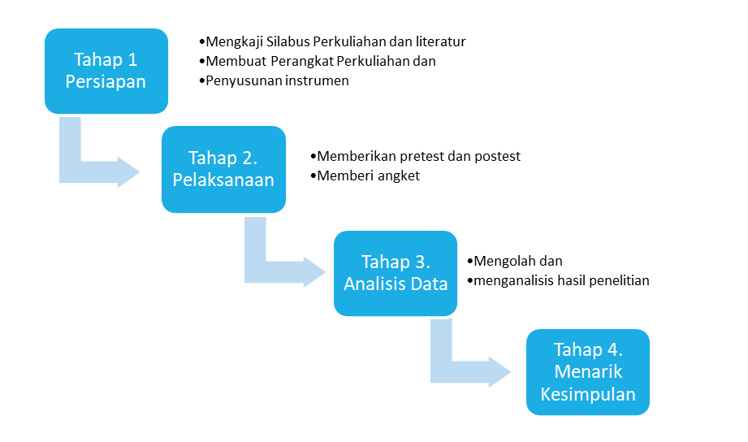
Figure 1. Proposed Research Roadmap

RESULT AND DISCUSSION
Based on research that has been carried out on Chemistry Education students in 1st semester of 2021/2022 several results. First, The teaching materials in this study were in the form of an articulate storyline for the Chemical Basics course used in learning in the experimental class. The teaching materials made consist of Basic Laws of Chemistry and Energetics which integrate materials, animations/videos/images as well as audio-visual explanations. The articulate storyline created was validated by 2 reviewers.
Table 1. Articulate Storyline Validity Results
No | Rated aspect | Suitability
No | Rated aspect | Yes | No
1 | Content: delivery of material on the articulate storyline that is presented to develop understanding of concepts and student self-efficacy | 2 | 0
2 | Visual Content: visual delivery of material has been facilitated in the articulated storyline that has been created | 2 | 0
3 | Audio Visual Content: the articulated is enough to facilitate students with audio explanations | 1 | 1
Presentase (%) |  | 83,3% | 1,67%

Overall, the articulated storyline made reached 83.3% validity according to reviewers. However, 1 reviewer stated that the audio-visual point is not correct, this is because the audio included in articulate is lacking because there is only a little explanation. However, researchers have their own reasons for this because of limited editing capabilities and the application used is not a paid application. Overall, the articulated that has been developed is feasible to be used as teaching material in research. Here is a little snippet of the teaching materials that have been made.

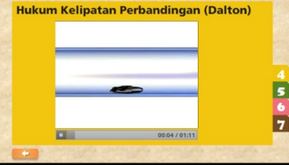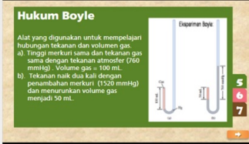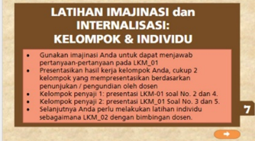
- (b) (c)
Figure 2. (a), (b), (c) Articulate Storyline snippet

Based on Figure 4.1, it shows that the articulated that has been made includes visual and audiovisual in accordance with Amiroh (2019) which states that the articulate storyline is one of the multimedia authoring tools used to create interactive learning media with content in the form of a combination of images, text, sound, graphics, videos, and animations. Research by NAK Sinta (2021) states that interactive learning media based on Articulate Storyline 3 with games on sub-theme 3 of the environment and its benefits, especially on science content, are suitable for use in learning.

Second results is Improving Student Self-Efficacy and Mental Model. Based on the results of the analysis of student self-efficacy data, data obtained by classifying self-efficacy before using the articulate storyline in four categories, namely very high, high, medium, and low categories. The grouping can be seen in Figure 3.

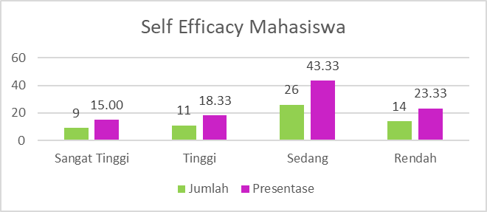
Figure 3. Overall Data of Student Self Efficacy before Treatment

Based on the picture, it is known that in general, the self-efficacy of students in both classes is categorized as moderate with a percentage achievement of 43.33% before the treatment, namely the use of articulate storylines.
There are three categories of increasing student self-efficacy, namely magnitude, strength, and generality. The magnitude category can be seen in Figure 4 below.
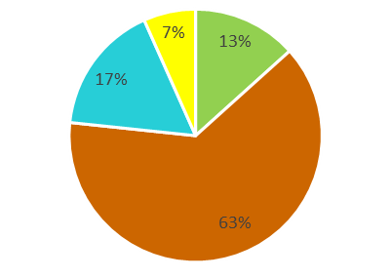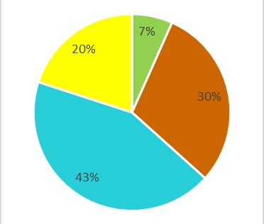
Figure 4. Distribution of Magnitude Aspects in Students' Self Efficacy

Figure 4 shows that the magnitude aspect of students in the experimental class is high, marked by 68% of students having an increase in the high magnitude aspect. While in the control class, the magnitude aspect of students is moderate, as many as 43% of students. Self efficacy in the magnitude aspect of the experimental class has increased compared to the control class which does not use the articulate storyline. This is because most students who were in the low category before learning to use articulate storylines experienced an increase in self-efficacy in the magnitude aspect which was quite good compared to the control class. So, articulate storylines are proven to increase self-efficacy in the magnitude aspect compared to using ordinary power points. The magnitude aspect is related to the difficulty of the task, whether it is a simple, medium, or high task. This is in line with the research of Ghozali & Rusmianto (2016) which states that the articulate storyline learning media provides a template that can be used for interactive media, especially for making test and practice questions. In addition, the program also makes it easier for users to publish online or offline so that it can be formatted in the form of CDs, word processing, personal pages and LMS.
The second aspect of student self-efficacy is the strength aspect, based on research data, most of the students in the experimental class were in the very high category, with a percentage of 56.67% with a total of 17 students. The following is Table 2 of the data found in the strength category.
Table 2. Distribution of Students in the Strength Category
Category | Experiment Class |  | Control Class
Category | Amount | Presentase (%) | Amount | Presentase  (%)
Very High | 17 | 56,67 | 3 | 10.00
High | 10 | 33,33 | 5 | 16.67
Medium | 2 | 6,67 | 13 | 43.33
Low | 1 | 3,33 | 9 | 30.00
30 100% |  |  | 30 | 100%

Based on Table 4.4, it is known that students who receive learning using articulate storylines in the experimental class have a greater strength aspect than students in the control class whose average students reach the medium category. This shows that the articulate storyline has succeeded in increasing students' self-efficacy abilities in the strength aspect because the articulate storyline integrates material, audio, and visual. The strength aspect is related to a person's stability towards his beliefs, in other words, the student's motivation in carrying out learning, whether it's doing assignments, answering quizzes, asking questions, etc. Students who are able to carry out self-regulated learning have a clear picture of how and why certain self-regulatory strategies should be used (Cheng, 2011). This is in accordance with the research of Setyaningsih et al (2020) which states that the use of interactive learning media based on articulate storylines is able to increase learning motivation and social studies learning outcomes for fourth grade elementary school students. In line with that, Sukmarini, et al (2021) stated that Articulate Storyline 3 is effective as an interactive learning medium to increase students' motivation to learn Arabic because it is at a high level of effectiveness.
The third aspect of self-efficacy studied is generality. The following is the distribution of students in the aspect of generality which is summarized in the bar chart in Figure 5.
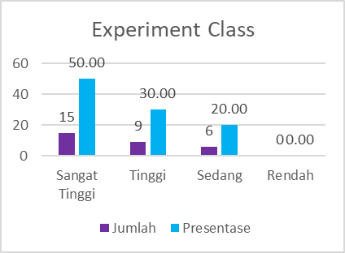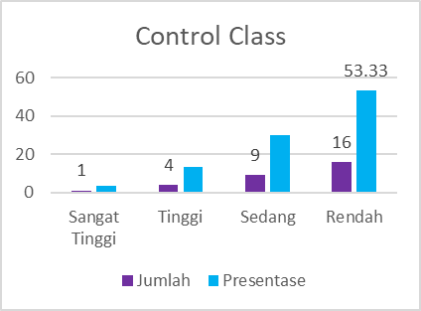
Figure 5. Overview of Students with Generality Aspect.
Figure 5 shows that in general, students in the experimental class have a very high generality aspect of 50.00% compared to the control class which is only 3.33%. On the other hand, in the control class, students in the low category were more dominant, namely 16 and in the experimental class, there were 0 students. This shows that after learning by using articulate storylines, experimental class students who previously had low and moderate aspects of generality began to increase their self-efficacy in the generality category. So, articulate storylines are able to improve student self-efficacy in the generality aspect very well compared to students who do not use articulate storylines. The aspect of generality is related to the area of ​​the task or behavior in other words, the attitude of students in conditioning their learning or learning independence is in the aspect of generality. According to Fardila and Arief (2021) in their research, they state that mobile learning based on articulate stroyline is feasible and effective to be used as a learning medium to improve self-regulated learning and student learning outcomes in archiving subjects.
This study also developed an improvement in students' mental models through analysis of students' pretest and posttest answers on 10 questions on the mental model test. In this study, using coding for verbal and non-verbal explanations of students according to Wang. The coding uses the types of student answers as an explanation of the students' non-verbal representations (Sunyono, 2014). The coding of the results of the mental model test is done by scoring each student's answer according to the type of student's answer (Sunyono, 2014). The scoring technique is done by assessing students' answers to test questions with descriptions using categories to determine the level of achievement.
The results of the analysis of student answers to mental models have diversity, so that the answers are grouped into several types according to the similarity of answers. The types are sorted from no attempt (no answer) to the most appropriate answer. Furthermore, the number of student answers in each type is expressed in percentages and interval criteria (Sudjana, 2005). The following is the percentage of students' mental model criteria before and after learning using the articulate storyline.
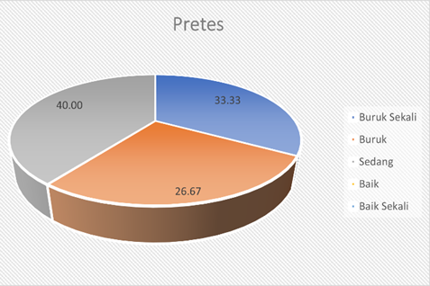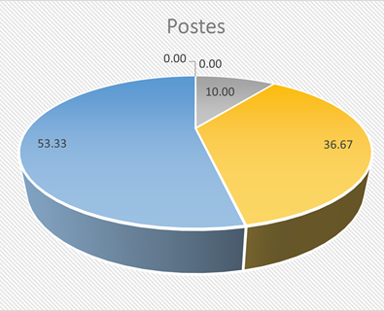
Figure 6. Percentage of Student Mental Models Criteria Before and After Learning with Articulate Storyline
Based on Figure 4.5, it is known that the mental model of students has increased after learning using the articulate storyline. This shows that the mental model of students which is characterized by concepts/explanations and structural drawings made by students is scientifically correct, which is marked by an increase in the percentage from 0% to 53.33%. Meanwhile, the "very bad" criterion shows a decrease in percentage of 33.33% which means that the mental models that have been brought by students since birth or mental models formed due to information from the wrong environment, or concepts and structural images created cannot at all accepted scientifically, or the learner does not have a concept or model that is not clear from a student experiencing a fairly good decline to 0%. So it can be concluded that learning using articulate storylines can develop students' mental models better than ordinary power points. This is in line with Mawarni (2016)'s research which states that guided inquiry learning has an effect on improving students' mental models and mastery of concepts on electrolyte and non-electrolyte solution materials.
Based on the research, students experience difficulties when faced with questions in the form of submicroscopic representation phenomena and reasoning in the form of contextual questions. However, after learning to use articulate storylines there were significant changes in the experimental class, namely in the mental model categories of 'medium', 'good', and 'very good'. The change in students' mental models mostly from "very bad" and "bad" to "good" and very good" indicates that overall students' mental models increase due to integration in learning using articulate storylines, namely between material, audio and audio visual. This is in accordance with research by Junaina (2013) which states that mental models are built based on experience by interpreting and explaining what has been seen and reflecting understanding at the submicroscopic level of a material in chemistry. According to Halim (2013) mental models are abilities that can develop according to one's needs in making predictions and solving problems in learning chemistry.
The pretest and posttest questions that have been made require students' reasoning in explaining a chemical phenomenon in three levels of representation, namely microscopic, submicroscopic, and symbolic. It is used to clearly see the integrity of the student's mental model in an effort to develop thinking and problem solving skills. One example is question number 5 below.
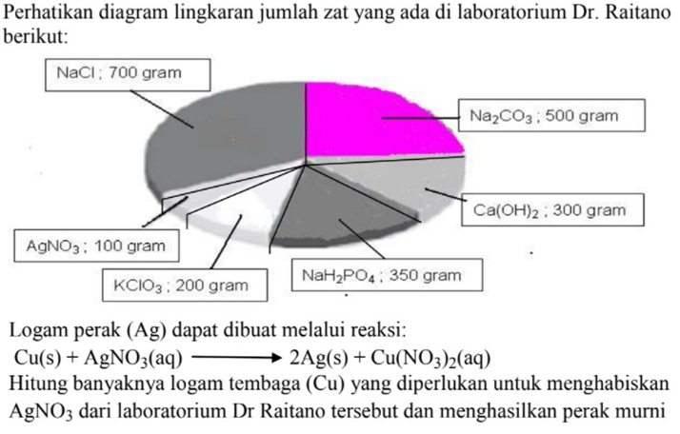
Figure 7. Examples of Student Mental Model Problems
Figure 7 shows that the problem requires an effort to solve the problem through the process of reasoning, explaining, predicting in words so that it can be solved. This is in accordance with the statement of Borges & Gilbert and Greca & Moreire that everyone uses mental models to make problem-solving efforts through the process of reasoning, explaining, predicting phenomena, or generating models that are expressed in various forms (such as diagrams, pictures, graphs, simulations or modeling, algebra/mathematics, and verbal descriptions in words or printed form) which can then be communicated to others (Sunyono, 2013). In other words, mental models require a high-level mindset, namely thinking higher than just memorizing facts or telling someone information (Heong, 2011).
Based on the analysis of the answers to question number 5, it is known that most of the students in the experimental class in their pretest could not fully describe the problem in question number 5 so that most of them did not answer and some students answered with wrong answers. While in the posttest, there was an increase in student thinking, marked by many students who answered correctly and some answered incorrectly but were able to describe the questions well (the process of answering the questions was correct). This shows that students' thinking patterns have begun to change from simple patterns to higher-order thinking patterns. According to Sange (Sunyono, 2013) a person's thought process requires building a good mental model so that someone is able to do problem solving well.

- CONCLUSION
Based on the results of data analysis and discussion that have been stated previously, it can be concluded that Articulate Storyline can significantly increase students' self-efficacy during distance learning in three aspects, namely magnitude, generality, and strength. Also, the mental model of students during distance learning using Articulate Storyline has been shown to improve significantly. Indicators of mental models that can be improved and have been implemented well are the student's ability to draw structural drawings, write reaction equations, and the ability of students to understand and explain a material concept in learning.

- REFERENCES
Agustina, M., & Bakti, A. M. (2015). Tingkat Kesiapan E-learning (E-learning Readiness) universitas Bina Darma sebagai Media Pembelajaran Pendidikan Jarak Jauh. Jurnal Ilmiah Matrik, 17(2), 123-132. Musfiqon. 2012. Pengembangan Media Belajar Dan Sumber Belajar. Jakarta : Prestasi Pustakakarya.
Amin Al-Habib, Syarif. (2020). Potensi Penggunaan Articulate Storyline 3.6 Berbasis Elearning Terhadap Hasil Belajar Mata Pelajaran Biologi Tingkat Sma Di Era Industri 4.0. Skripsi. Universitas Muhammadiyah Surakarta.
Amiroh. 2019. Mahir Membuat Media Interaktif Articulate storyline. Yogyakarta: Pustaka Ananda Srva.
Cheng, C.K. (2011). The Role of Self-regulated Learning in Enhancing Learning Performance. International Journal of Research, 6, 1-16.
Darmawan, D. (2012). Inovasi Pendidikan. Bandung: Rosda Karya.
Fardila, S., & Arief, M. (2021). Pengembangan mobile learning berbasis articulate storyline 3 pada mata pelajaran kearsipan untuk meningkatkan self regulated learning dan hasil belajar siswa (studi pada kelas x OTKP di SMK Cendika Bangsa Kepanjen). Jurnal Ekonomi, Bisnis dan Pendidikan, 1(4), 344-356.
Ghozali, F. A. And Rusimamto, P. W. (2016) ‘engembangan Media Pembelajaran Berbasis Articulate Studio’13 Kompetensi Dasar Arsitektur dan Prinsip Kerja Fungsi Setiap Blok Plc Di Smk Negeri 1 Sampang’, Jurnal Pendidikan Teknik Elektro, 1. 5(1).
Halim, N.D. Abd. 2013. Mental Modelin Learning Chemical Bonding : A Preliminary Study Procedia. Social and Behavioral Science, 0 (0), hlm. 000-000.
Heong, Y. M & Othman. 2011. The Level of Marzano Higher Order Thinking Skills among Technical Education Students. International Journal of Social and humanity, Vol. 1, No. 2, July 2011. 121-125.
Junaina. 2013. Pengaruh Pembelajaran Kerangka IFSO terhadap Peningkatkan Model Mental dan Penguasaan Konsep Ikatan Kimia Siswa SMA Negeri 1 Way Lima.(Tesis). Program S2 Teknologi Pendidikan. Program Pascasarjana Universitas Lampung: tidak dipublikasikan.
Kemendikbud. (2012). Permendikbud No. 24 tentang Penyelenggaraan Pendidikan Jarak Jauh pada Pendidikan Tinggi. Jakarta: Kementrian Pendidikan dan Kebudayaan.
Kementerian Riset, Teknologi, dan Pendidikan Tinggi. 2016. Kebijakan Pendidikan Jarak Jauh dan E-Learning di Indonesia. http://kopertis3.or.id/v2/wp-content/uploads/Paulina-Pannen-KebijakanPJJ-dan-Learning.pdf.
Mawarni, D. 2016. Pembelajaran Inkuiri Terbimbing Dalam Meningkatkan Model Mental Siswa Dan Penguasaan Konsep Siswa Pada Materi Larutan Elektrolit Dan Non Elektrolit.(Skripsi). Universitas Lampung. Bandar Lampung.
Rafmana, Chotimah, dan Alfiandra. (2018). Pengembangan Multimedia Interaktif Berbasis Articulate Storyline Untuk Meningkatkan Motivasi Belajar Siswa Pada Mata Pelajaran Pkn Kelas Xi Di Sma Srijaya Negara Palembang. Jurnal Bhineka Tunggal Ika, 5 (1), hlm. 52-65.
Rianto. (2020). Pembelajaran Interaktif Berbasis Articulate Storyline 3. Indonesian Language Education and Literature, 6 (1), 84-92.
Setiawan, Adib R. (2020). Lembar Kegiatan Saintifik untuk Pembelajaran jarak Jauh Topik Penyakit Coronavirus 2019 (Covid-19), Edukatif: Jurnal Ilmu Pendidikan, 2 (1), 28-37.
Setyaningsih, S., Rusijono, R., & Wahyudi, A. (2020). Pengaruh penggunaan media pembelajaran interaktif berbasis Articulate Storyline terhadap motivasi belajar dan hasil belajar siswa pada materi Kerajaan Hindu Budha di Indonesia. Didaktis: Jurnal Pendidikan dan Ilmu Pengetahuan, 20(2).
Sinta, N. A. K., Astawan, I. G., & Suarjana, I. M. (2021). Belajar Subtema 3 Lingkungan dan Manfaatnya dengan Media Pembelajaran Interaktif Berbasis Articulate Storyline 3. MIMBAR PGSD Undiksha, 9(2).
Sudjana, N. (2005). Metode Statistika. Transito. Bandung.
Sukmarini, F., Mauludiyah, L., Roziqi, M. A., & Nurdianto, T. (2021). Interactive Arabic Learning Media based on Articulate Storyline 3 to Increase Students' Motivation/Pemanfaatan Articulate Storyline 3 sebagai Media Pembelajaran Interaktif untuk meningkatkan Motivasi Belajar Bahasa Arab Siswa. al Mahāra: Jurnal Pendidikan Bahasa Arab, 7(1), 106-121.
Sunyono. 2013. Buku Model Pembelajaran Berbasis Multipel Representasi (Model SiMaYang). Aura Press. Bandar Lampung.
Sunyono. 2014. Model Pembelajaran Kimia Berbasis Multiple Representasi dalam Membangun Model Mental Mahasiswa pada Mata Kuliah Kimia Dasar. (Disertasi) (tidak diterbitkan). Universitas Negeri Surabaya. Surabaya.
Wang, C. Y. 2007. The Role of Mental-Modeling Ability, Content Knowledge, and Mental Models in General Chemistry Students' Understanding About Molecular Polarity.(Doctoral dissertation). University of Missouri.Columbia.
Yahya, R., dkk. (2020). Pengembangan Perangkat Pembelajaran Flipped Classroom Bercirikan SJME (Supremum Journal of Mathemathics Education), 4(1), 78–91.

