PENGEMBANGAN LKPD INKUIRI BERBANTUAN INTERNET ASSISTED LEARNING UNTUK MELATIHKAN KETERAMPILAN BERPIKIR KRITIS PADA SUBMATERI LAJU REAKSI

Kuny Abidatul Mahmudah dan *Bertha Yonata
Jurusan Kimia FMIPA Universitas Negeri Surabaya
*Correspondinge-mail : berthayonata@unesa.ac.id

Received: datemonth year Accepted: datemonth year Online Published: datemonth year

Abstract: Development of Student Worksheet Based on Inquiry and Internet Assisted Learning to Practice Critical Thinking Skills in Submateries of Reaction Rates. This study aims to determine the feasibility based of Inquiry student worksheets based on Internet Assisted Learning in the reaction rate submaterial to practice critical thinking skills of class XI SMA students. The development research design uses the 4-D method (Define, Design, Develop, and Dissiminate). In this research it is up to the development stage. The trial was carried out on 24 high school class XI students who had not received material on the reaction rate on November 9-20 2020. The research instrument consisted of a review sheet, a validation sheet, a student response questionnaire, a knowledge test sheet, and a critical thinking skill test sheet. The results showed that the student worksheet was very feasible based on the assessment of the validator and student responses of ≥ 81% and achieving a value of ≥ 75 according to the criteria for minimum learning completeness. The validator's assessment based on the eligibility of the content, language, presentation, and graphic criteria showed the percentage of 98.6%, 86.4%, 85,4%, and 100% in the very valid category. Student response shows a positive response assessment based on the eligibility of the content, language, presentation, and graphic criteria showed the percentage criteria of content is 91.8% , language is 81.7%, presentation is 85%, and graphic 96.7%. The results of the knowledge test obtained an n-gain score of 0.85 in the very high category. The results of the creative thinking skills test obtained an n-gain score of 0.795 in the very high category.
Keywords: Student Worksheet (LKPD), Inquiry, Critical Thinking Skills, Reaction rate.

Abstrak: Pengembangan Lkpd Inkuiri Berbantuan Internet Assisted Learning untuk Melatihkan Keterampilan Berpikir Kritis pada Submateri Laju Reaksi. Penelitian ini bertujuan untuk mengetahui kelayakan LKS Inkuiri siswa berbasis Internet Assisted Learning pada materi Laju Reaksi Praktik Keterampilan Berpikir Kritis siswa kelas XI SMA. Rancangan penelitian pengembangan menggunakan metode 4-D (Define, Design, Develop, dan Dissiminate). Penelitian ini hanyasampai pada tahap pengembangan. Uji coba dilakukan terhadap 24 siswa kelas XI SMA yang belum mendapatkan materi tentang laju reaksi pada 9-20 November 2020. Instrumen penelitian terdiri dari lembar telaah lembar validasi, lembar angket respon siswa, lembar tes pengetahuan, dan lembar tes keterampilan berpikir kritis. Hasil penelitian menunjukkan bahwa LKS sangat layak berdasarkan penilaian validator dan respon siswa ≥ 81% serta mencapai nilai ≥ 75 sesuai kriteria ketuntasan belajar minimal. Penilaian validator berdasarkan kriteria kriteria isi, bahasa, penyajian, dan grafik menunjukkan persentase 98.6%, 86.4%, 85,4%, and 100% dalam kategori sangat valid. Respon siswa menunjukkan penilaian respon positif berdasarkan kriteria kelayakan isi, bahasa, presentasi, dan grafik menunjukkan kriteria persentase isi 91.8%, bahasa 81.7%, presentasi 85%, dan grafik 96.7%. Hasil tes pengetahuan diperoleh skor n-gain 0.85 dengan kategori sangat tinggi. Hasil tes keterampilan berpikir kreatif diperoleh skor n-gain sebesar 0.795 dengan kategori sangat tinggi.
Kata kunci: Lembar Kerja Siswa (LKPD), Inkuiri, Keterampilan Berpikir Kritis, Laju reaksi

Untuk mengutip artikel ini:

Mahmudah, Kuny Abidatul dan Yonata, Bertha. (2020). Pengembangan Lkpd Inkuiri Berbantuan Internet Assisted Learning untuk Melatihkan Keterampilan Berpikir Kritis pada Submateri Laju Reaksi. Jurnal Pendidikan dan Pembelajaran Kimia, Vol(No), Page-Page.

- INTRODUCTION
Chemistry is one of the groups of Natural Sciences (IPA). According to Permendikbud (2013), the purpose of learning chemistry is students are expected to be able to relate chemical concepts, principles, laws, and theories in solving problems in everyday life and technology. Whereas chemistry learning has the potential for a very interesting learning because it is related to natural phenomena. Students have ability to analyze natural phenomena that needed skill in the 21st century era.
Based on the National Education Association 21st century skills include 4C, namely critical thinking skills, creativity, communication, and collaboration. 21st century learning should create the conditions to fulfill these four components. One of the most important components is critical thinking skills. Critical thinking skills can be trained by connecting chemistry with the real world. Critical thinking skills is needed to be succeed in real life (Mulyani, Rudibyani, & Efkar, 2018).
Critical thinking is a skill to carry out various analyzes, assessments, evaluation, reconstruction, decision-making that leads to rational and logical actions (Redhana, 2019). Critical thingking skills formulates six components of critical thinking, namely interpretation, analysis, evaluation, inference, explanation and self regulation (Facione, 2011). The ability to think critically can be grown through scientific work, such as practicum. This activity can improve mastery of the material by provoking student reasoning through problem solving by asking questions in accordance with the Bloom Taxonomy domain, namely C4 (analyzing), C5 (evaluating), and C6 (creating) (Filsaime, 2008).
In 2015, The results of Program For International Student Assessment (PISA) showed that Indonesian students are still classified as low in science, reading and mathematics which require High Order Thinking Skills (HOTS) such as problems related to solving real life problems (OECD, 2016). The weak level of critical thinking of students such as students have not been able to analyze arguments, consider whether sources are reliable or not, make and determine the results of considerations, identify assumptions, and determine an action (Mulyani, Rudibyani, & Efkar, 2018).
Inquiry-based learning pedagogy emphasizes that learning with technologies can help reach 21st century goals. The inquiry learning model has phases that can lead to the cognitive domains of C4 (analyzing), C5 (evaluating), and C6 (creating). This is in the data collection phase and analysis is the C4 cognitive domain, proposing hypotheses and drawing conclusions is the C5 cognitive domain, and carrying out experiments is the C6 domain (Aksela, 2005). So that learning chemistry with this learning model is expected to improve students' critical thinking skills.
Inquiry learning model has several levels and types. According to Arends (2012) the stages of inquiry learning are divided into 6 stages, namely (1) getting attention and explaining the inquiry process; (2) presents inquiry problems or inconsistent events; (3) asking students to formulate a hypothesis to explain the problem or event; (4) encourage students to collect data to test hypotheses; (5) formulating explanations and / or conclusions; (6) reflects on the problematic situation and the thought processes used to investigate it. The teacher only helps and facilitates the learning process, guides students with questions, investigates behavior and uses observational data to develop explanations and answer their questions (Dewita & Ahda, 2019).
During the Covid-19 pandemic, the form of lectures that can be used as a solution is online learning (Sadikin & Hamidah, 2020). One indication of this phenomenon is a change in the learning process where interaction between teachers and students takes place not only through face-to-face relationships, but also with communication media such as computers, Internet, etc (Purwanto, et al., 2020). An inquiry-based learning approach to optimize the design and development of virtual online learning activities (Chanprasitchai & Khlaisang, 2016). Students can find authentic digital study materials from real-life (e.g. a digital video), and useful information and Internet links for their studies in chemistry (Aksela, 2005).
The material that must be taught and studied by students has been stated in the Regulation of the Minister of Education Number 719 of 2020. Basic Competence (KD) Number 3.4 Describes the factors that affect the rate of reaction using collision theory and its application in everyday life. The basic competency asks students to explain the reaction rate factors and their applications. This demands a C3 cognitive level (explaining). Meanwhile, KD 4.5 Designing and concluding and presenting the experimental results of the factors that affect the reaction rate.
The basic competencies used are KD 3.4 and 4.5. This is because KD 4.4, which reads "presents the results of tracing information on ways of regulating and storing materials to prevent uncontrolled physical and chemical changes" does not match the material discussed in this study.
One of the teaching materials, namely Student Worksheets or LKPD which is useful for improving students' critical thingking skills in the learning process. Student Worksheets (LKPD) are student guides which is used to carry out investigative activities or problem solving (Wulandari, et al., 2017). Student Work Sheet (LKPD) can be a guide for aspect development exercises cognitive as well as a guide for the development of all aspects of learning in the form of experimental guides or demonstration (Trianto, 2012). The existence of innovative worksheets will create more enjoyable learning.
Student worksheet based on guided inquiry increasing n-gain into medium category (Piawi, Nizar, & Mawardi, 2018). Guided inquiry-based worksheet on collodial material for grade XI student is effective use in the learning process because can reach n-gain into 0.44 in medium category (Damaianti, Mawardi, & Oktavia, 2019). Learning using LKPD based on inquiry can train critical thinking skills (Apriyana, et al., 2019).
Based on the above background, a Student Worksheet Based On Inquiry And Internet Assisted Learning To Practice Critical Thinking Skills In Submateries Of Reaction Rates was developed. It is expected that students can get the concept well so that student learning outcomes can achieve the desired teaching and learning completeness criteria by practicing critical thinking skills.
- METHOD
Development research is carried out with a 4-D development design which includes, defining, planning, developing and disseminating (Sugiyono, 2015). In this research, the dissemination stage, but only until the develop stage. A limited trial was conducted to determine the feasibility of the LKPD that had been developed by obtaining practicality and effectiveness values.
The research instruments used include study sheets, validation sheets, student response questionnaires supported by student activity observation sheets, knowledge test sheets, and critical thinking skills test sheets. The study results were analyzed descriptively. The results of the validation were carried out by two chemistry lecturers of Faculty of Mathematics and Natural Sciences Unesa and one chemistry teacher at MAN 1 Gresik. The students' worksheets developed were analyzed using a quantitative descriptive method through percentages. The percentage obtained by comparing the scores from the data collection results from all validators with the criteria score. The assessment uses the calculation of the Likert Scale which is presented in Table 1.
Table 1. Validation Assessment Criteria
Score | Criteria
5 | Very suitable
4 | Suitable
3 | Quite suitable
2 | Less suitable
1 | Not suitable
(Riduwan, 2013)
Validation data were analyzed using a formula :
%Percentage= $\frac{Σ score obtained}{ Σ score criteria }x100\%$
Score criteria = highest score for each item x number of items x number of respondents.
The percentage can then be perceived into the categories referred to in table 2 below:
Percentage | Criteria
0% - 20% | Not valid
21% - 40% | Less valid
41% - 60% | Quite valid
61% - 80% | Valid
81% - 100% | Very Valid
Table 2. Validation Results Criteria

(Riduwan, 2013)
LKPD can be said to be very valid if the presentation is more than equal to 81%. The results of the student response questionnaire were supported by student activity observation sheets. Analysis of the student response questionnaire based on the scores obtained from positive and negative questions and measured using the Guttman scale presented in table 3.
Table 3. Guttman Scale
Question | Answer | Score
Positive | Yes | 1
Positive | No | 0
Negative | Yes | 0
Negative | No | 1

Futhermore, the calculated data using Guttman scale, the percentage is calculated is calculated using the formula
% Percentage = $\frac{Σ skoce obtained}{score maksimum}x100\%$
The results of the student response questionnaire analysis were used to determine the practicality of the Student Worksheets developed using the interpretation of scores in Table 4. LKPD is said to be very practical if student responses reach a percentage of ≥ 81%.
Table 4. Student Response Scores Criteria
Percentage | Criteria
0% - 20% | Not responsive
21% - 40% | Less responsive
41% - 60% | Quite responsive
61% - 80% | Responsive
81% - 100% | Very responsive

Student activity observation sheets are used to observe student activities during limited trials. The analysis was carried out by descriptive quantitative. The results of the data are calculated using a formula:
% Student activity = $\frac{Σ the frequency of activity that appears}{Σ the total frequency of activity}x100\%$
The percentage can then be perceived into categories that refer to the following table 5:
Table 5. Observation Results Criteria
Perecentage | Criteria
0% - 20% | Not practical
21% - 40% | Less practical
41% - 60% | Quite practical
61% - 80% | Practical
81% - 100% | Very practical
(Riduwan, 2013)
The results of observing the activities of students can be said to be very practical if they get a presentation of more than 81%.
Cognitive learning outcome data were analyzed descriptively quantitative. The data obtained through the test sheet of students' knowledge of the reaction rate material. The developed LKPD is seen from individual completeness and classical completeness.
Classical completeness = $\frac{the number of students who completed}{the total number of students}x100\%$
The completeness of the learning outcomes for the knowledge obtained from the pre-test and post-test scores was set with a value of ≥75, while for classical completeness it was ≥75% and the post-test classical completeness was greater than the pre-test classical completeness.
To find out the critical thinking skills, it can be determined by calculating all the average pre test and post test scores using the N-gain score which can be calculated using the formula:
N-gain score = $\frac{skor posstest - skor pretest}{skor maksimum-skor pretest}$
The N-gain score that has been obtained can be interpreted according to the categories in table 6 below:
Table 6. N-gain Score Category
N-gain | Category
≥ 0,7 | High
0,3 ≤ g < 0,7 | Medium
0,0 ≤ g < 0,3 | Low

- RESULT AND DISCUSSION
The research entitled "Development Of Student Worksheet Based on Inquiry and Internet Assisted Learning to Practice Critical Thinking Skills In Submateries Of Reaction Rates" aims to develop and produce proper worksheets and then be tested on 24 students which aims to obtain data on students' critical thinking skills and student responses to LKPD that developed.
During the Covid-19 pandemic, the form of lectures that can be used as a solution is online learning (Sadikin & Hamidah, 2020). So the LKPD tested on 24 students utilize by google classroom to share announcement, google meet to communicate through face-to-face relationships (Purwanto, et al., 2020), and google form to distribute the questionnarie (Sadikin & Hamidah, 2020). Pre test and post test of cognitive and critical thinking skills given by google form.
Validity of Student Worksheets
Development research is carried out with a 4-D development design which includes, defining, planning, developing and disseminating (Sugiyono, 2015). In this research, the dissemination stage, but only until the develop stage.
- Defining Stage
Define the requirements for the preparation of the LKPD. Analyzing the problems carried out with field studies is the first step to develope student worksheets and then continues with product design. Defining analysis is carried out according to the needs including student analysis, task analysis, concept analysis and indicator specifications (Damaianti, Mawardi, & Oktavia, 2019). Student analysis aimed to determine characteristics of learners that will serve as a research subject. Concept analysis is to review of literature and look at the appropriateness of the worksheet contents and manner of presentation. Then followed by analysis of the curriculum to determine the material accordance with Core Competencies & Basic Competencies. Then specificate the indicators and learning objectives to be achieved in student worksheet.
- Designing Stage
Product design planning is the design of student worksheets components consisting of : (a) cover, (b) pages of Core Competencies & Basic Competencies, (c) information other supporters (Triyono & Suparman, 2019). The design of these components is presented in the following pictures :
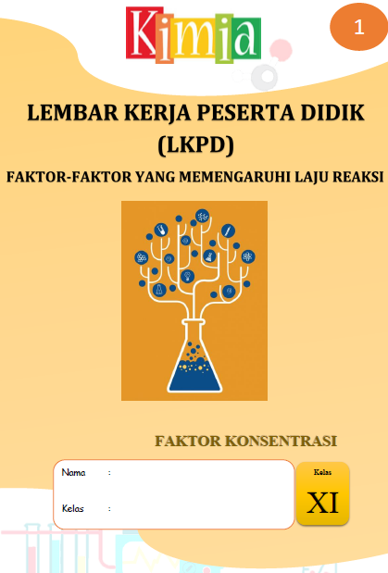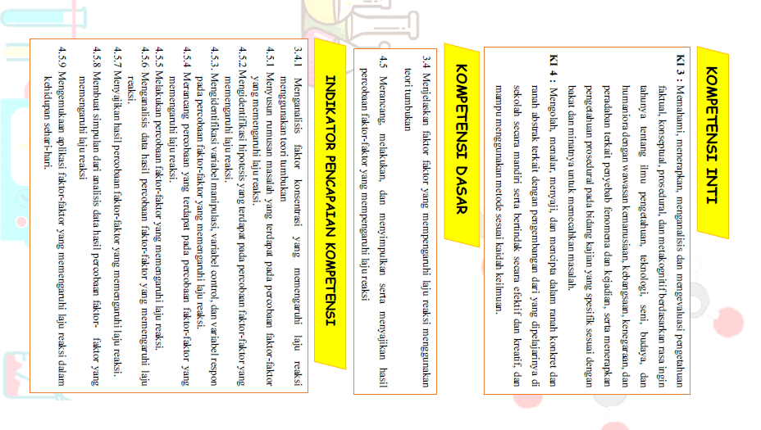
Figure 1. Cover Figure 2. Core Competencies & Basic Competencies
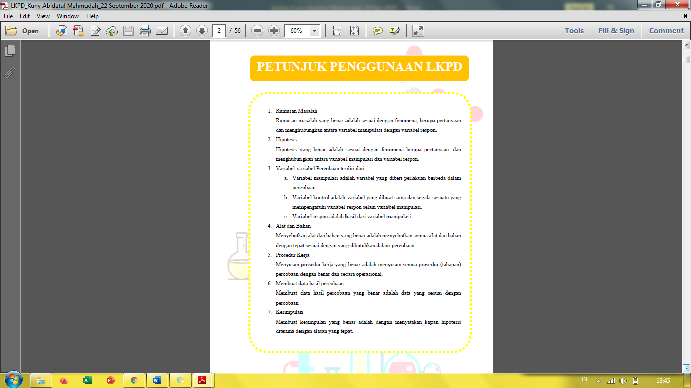
Figure 3. Supporters

- Developing Stage
Validation with two chemistry lecturers and chemistry teachers, and limited trials. The following stage will be described as :
- Review
The study result data is in the form of qualitative descriptive data. The data is in the form of suggestions and input from the analysis of experts in the field of chemistry education to be used to improve learning tools and research instruments.
- Validation
This analysis uses a quantitative descriptive method by providing an assessment of the learning tools that have been revised according to the percentage. Validation criteria are in the form of content, language, presentation, and graphic criteria.
The results of the validation were carried out by two chemistry lecturers of Faculty of Mathematics and Natural Sciences UNESA and one chemistry teacher at MAN 1 Gresik. The students' worksheets developed were analyzed using a quantitative descriptive method through percentages. LKPD can be said to be valid if the presentation is more than equal to 61%.
Table 7. Validation Result
Criteria Valued | Percentage | Criteria
Contents | 93,3% | Very valid
Language | 91,6% | Very valid
Presentation | 90,47% | Very valid
Graphic | 91,6% | Very valid
Based on Table 7, the percentage of content criteria is the highest. It means that the LKPD that developed is suitable with the Basic Competencies (KD) students that has been stated in the Regulation of the Minister of Education Number 719 of 2020.
The percentage of language and graphic has the same value. The language criteria of term consistency, easy to understand, and effective and efficient reach 93,3%. The lowest percentage in language criteria is indicator of the use of good and correct Indonesian language is 86,67%. Therefore, the writer must improve the accordance of sentences based on KBBI.
The graphic criteria of interesting cover, font is easy to read, and harmonious layout reach 93,3%. The lowest percentage in graphic criteria is the quality of the picture and video reach 86,67%.
Practicality of Student Worksheets
Student response questionnaires are used to determine the practicality of the student worksheets. There are ten question in the questionnaires. The content criteria are the number of 2,7, and 8. The language criteria are the number of 1, 6, 9, and 10. The presentation are the number of 3 and 4. The graphic criteria is the number of 5. Student response results data are presented in Table 8.
Table 8. Student Response Questionnaires
Criteria Valued | Average Percentage | Criteria
Contents | 98,6% | Very Responsive
Language | 86,4% | Very Responsive
Presentation | 85,4% | Very Responsive
Graphic | 100% | Very Responsive
Content criteria ask about how this LKPD can train the student skills to solve a problem, how to make a formulation problem and hyphotheses, and how to express a conclusion. Only 3 students that disagree this statement.
Language criteria ask about the explanation are easily to understand, interesting, helpful to be more understand in the material, and foster curiosity. Inquiry based worksheets that are developed make it easier for teachers to achieve learning goals and facilitate teachers to improve student activities in learning (Damaianti, Mawardi, & Oktavia, 2019). Same statement from student response that written in the questionnaires that distributed by google form.
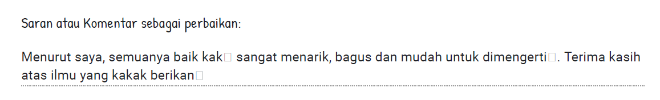
Figure 4. Student Respons
Presentation criteria ask about how video LKPD can train the student to more understand about the material and improve their critical thinking skills. From the presentation criteris that the content of the material on the worksheets with the competencies achieved is appropriate (Damaianti, Mawardi, & Oktavia, 2019).
The last criteria is graphic. This criteria ask about how the pictures and ilustration in the LKPD can help student to understand in the concept. Based on the statement from student respons, the LKPD can improve the understanding’ student in the material.
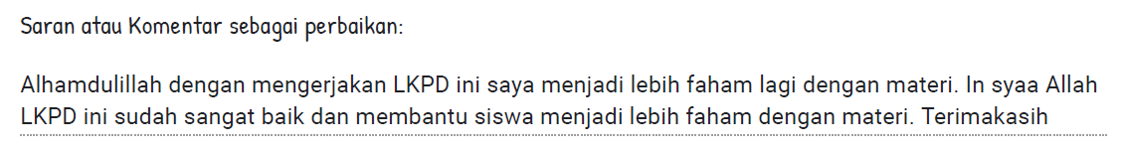
Figure 5. Student Respons
Based on the results of the student response questionnaire, the developed worksheets have reached a percentage of ≥ 81% in the very responsive category. This is harmonized with the results of observations of student activity, which is 93,62% relevant activity for both classes. The results of student response questionnaire and observations of student activity can be said to be very practical because of the percentage of more than 81%.
The Effectiveness of Student Worksheets
The effectiveness of student worksheet was carried out on 12 students in class A and 12 students in class B by giving the same treatment. The test is carried out based on the pre test and post test scores of cognitive and critical thinking skills test by utilize google form. Because during the Covid-19 pandemic, the form of lectures that can be used as a solution is online learning (Sadikin & Hamidah, 2020).
Cognitive of knowledge questions’ test accordance with the domains of C3 (application) and C4 (analyzing). The data from the pre test and post test were analyzed using n-gain. The results of the n-gain value of cognitive test can be seen in Table 9.
Table 9. Cognitive N-gain Result
$\overline{x}$ Value |  |  |  | $\overline{x}$ N-Gain |  | Criteria
$\overline{x}$ Pretest |  | $\overline{x}$ Posttest
A | B | A | B | A | B | A | B
65 | 26 | 97,5 | 87,5 | 0,87 | 0,83 | High | High
From the results of the pre test and post test, both of class obtained the cognitive 0,85 n-gain score criteria in the high category. The percentage of completeness of learning outcomes for 24 students is 100%. Based on the results of the pre test and post test answers, it was known that there were some students who did not increasing in cognitive questions.
Critical thinking skills formulates six components, namely interpretation, analysis, evaluation, inference, explanation and self regulation (Facione, 2011). In this LKPD, we will only use four components of critical thinking, namely interpretation, analysis, inference, explanation. Critical thinking skills questions’ test accordance with the indicators of critical thinking skills. The results of the n-gain value of critical thinking test can be seen in Table 10.
Table 10. Critical Thinking N-gain Result
$\overline{x}$ Value |  |  |  | $\overline{x}$ N-Gain |  | Criteria
$\overline{x}$ Pretest |  | $\overline{x}$ Posttest
A | B | A | B | A | B | A | B
44 | 30 | 86,7 | 88 | 0,76 | 0,83 | High | High
From the results of the pre test and post test, the final n-gain for both class is 0,795 in high category. The lowest pre test score is 32 in A class and 25 in B class. After being trained in Inquiry Student Worksheets, the lowest post test score is 75 in both class and there is a student in each class reach 100 score.
Based on the results of the pre test scores, interpretation stage only reaches average 38,5% and the post test score is 90,625%. Interpretation is skills to comprehend and express the significance of a wide variety of procedures, or criteria (Facione, 2011). In this LKPD, student can improve their skills to express the significance of a wide variety of procedures, or criteria by formulation of problem or phenomena. Interpretation stage seen in the second stage of inquiry learning that was presents inquiry problems or inconsistent events (Arends, 2012). Despite of using online learning, an inquiry-based learning approach to optimize the design and development of virtual online learning activities (Chanprasitchai & Khlaisang, 2016).
Based on the results of the pre test scores, inference stage reaches 34,9% and the post test score is 94,3%. Inference is skills to form hypotheses and to educe the consequences to forms of representation (Facione, 2011). In this LKPD, student can improve their skills to formulate hypotheses and establish conclusion. Inference stage seen in the third stage of inquiry learning that was asking students to formulate a hypothesis to explain the problem (Arends, 2012).
Based on the results of the pre test scores, analysis stage only reaches average 42,2% and the post test score is 75,5%. Analysis is skills to identify the intended and actual inferential relationships among questions, concepts, descriptions, or other forms of representation intended to express reasons (Facione, 2011). One of indicators is observe results by stating interpretation (Safitri, Kadaritna, & Tania, 2019). In this LKPD, student can improve their skills to express the reasons by answer questions based on observing result from the experiment result that their done or watching video and relate them to initial knowledge. Analysis stage seen in the four stage of inquiry learning that was encourage students to collect data to test hypotheses (Arends, 2012).
Based on the results of the pre test scores, explanation stage only reaches average 43,75% and the post test score is 69,8%. Explanation is skills to state the results of one’s reasoning in terms of the conceptual, methodological, and contextual considerations (Facione, 2011). In this LKPD, student can improve their skills to state the reasons by answer questions based on the facts from the experiment result and relate them to theory. Explanation stage seen in the sixth stage of inquiry learning that was reflects on the problematic situation and the thought processes used to investigate it (Arends, 2012).
The evaluation is lower than learning outcomes, but there are 11 student who can explain perfectly. The results of cognitive and critical thinking test the LKPD can be said to be very effective because of the n-gain more than 0,7 in high criteria. This activity can improve mastery of the material by provoking student reasoning through problem solving by asking questions in accordance with the Bloom Taxonomy domain, namely C4 (analyzing), C5 (evaluating), and C6 (creating) (Filsaime, 2008).
Based on Apriyana, et al., (2019), learning using LKPD based on inquiry can train critical thinking skills. Based on Piawi, Nizar, and Mawardi (2018), student worksheet based on guided inquiry increasing n-gain into medium category. Based on Damaianti, Mawardi, and Oktavia (2019), guided inquiry-based worksheet on collodial material for grade XI student is effective use in the learning process because can reach n-gain into 0.44 in medium category. This research proves that Student Worksheet Based on Inquiry and Internet Assisted Learning Submateries Of Reaction Rates can train critical thinking skills seen by reach n-gain 0,795 in high category.
- CONCLUSION
Based on the research results, it can be concluded that LKPD based on inquiry assisted by Internet Assisted Learning to train students' critical thinking skills is feasible. The results of the validation for content, language, presentation and graphic criteria show the percentage of 91,8%, 81,7%, 85%, and 96,7% with very valid categories. This shows that the LKPD is very valid. The results of the student response questionnaire in criteria of content is 98,6% , language is 86,4%, presentation is 85,4%, and graphic 100% categorized in very positive responsive and supported by the activity observation sheet that had been carried out at 93,62%. This shows that the LKPD is very practically. The results of cognitive and critical thinking skills get n-gain scores of 0,85 and 0.795 with the high category. Each component of critical thinking includes interpretation, inference, analysis, evaluation, and explanation. This shows that the LKPD is effective.

- REFERENCES
Aksela, M. (2005). Supporting Meaningful Chemistry Learning and Higher-order Thinking through Computer-Assisted Inquiry: A Design Research Approach. Helsinki: Chemistry Education Center, Department of Chemistry, University of Helsinki.
Apriyana, N., Herlina, K., & Abdurrahman. (2019, September). PENGEMBANGAN LEMBAR KERJA SISWA BERBASIS INKUIRI TERMBIMBING UNTUK MENINGKATKAN KEMAMPUAN BERPIKIR KRITIS. Jurnal Pendidikan Fisika, 7(2), 92-96.
Arends, I. R. (2012). Learning to Teach 9th ed. New York: Mc Graw Hill.
Association, N. E. (2012). Preparing 21st century students for a global society: An educator's guide to "the four Cs". Washington DC: National Education Association.
Chanprasitchai, O.-a., & Khlaisang, J. (2016, October). Inquiry-Based Learning for a Virtual Learning Community to Enhance Problem-. The Turkish Online Journal of Educational Technology, 15(4), 77-87.
Damaianti, O., Mawardi, & Oktavia, B. (2019). Development of Guided Inquiry-based Worksheets on Colloidal Material for Chemistry Learning Grade XI in Senior High School. International Journal of Progressive Sciences and Technologies , 13-19.
Dewita, R., & Ahda, Y. (2019). Improvement of Critical Thinking Skills of Students of Class X Mia Man 3 Kota Padang Panjang Using Guided Inquiry Learning Model . International Journal of Progressive Sciences and Technologies, 142-147.
Facione. (2011). Critical Thinking: What It Is and Why It Counts. Hermosa Beach: Measured Reasons LLC.
Filsaime, D. (2008). Menguak Rahasia Berpikir Kritis dan Kreatif. Jakarta: Prestasi Pustakarya.
Mulyani, S. D., Rudibyani, R. B., & Efkar, T. (2018). Efektivitas LKS Berbasis Multipel Representasi dalam Meningkatkan Kemampuan Berpikir Kritis. Jurnal Pendidikan dan Pembelajaran Pendidikan Kimia, 1-12.
Permendikbud. (2013). Tentang Standar Kompetensi Lulusan Nomor 54 . Kementerian Pendidikan dan Kebudayaan Indonesia.
Permendikbud. (2020). Regulation of the Minister of Education Number 719 : KI dan KD Esensial. Kementerian Pendidikan dan Kebudayaan Indonesia .
Piawi, K., Nizar, U. K., & Mawardi. (2018). Development of student worksheet based on guided inquiry with. International Conferences on Education, Social Sciences and Technology (hal. 679-683). Padang: ICESST 2018.
Purwanto, H., Hamka, D., Ramadhani, W., Mulya, D., Suri, F., & Novaliza, M. (2020). Problematics Study of Natural Sciences (IPA) Online at Junior High School in the Time of the Pandemic Covid-19. International Journal of Progressive Sciences and Technologies , 188-195.
Redhana, I. W. (2019). MENGEMBANGKAN KETERAMPILAN ABAD KE-21 DALAM. Jurnal Inovasi Pendidikan Kimia, 13(1), 2239-2253.
Riduwan. (2013). Skala Pengukuran Variabel-variabel Penelitian. Bandung: PT Alfabeta.
Sadikin, A., & Hamidah, A. (2020). Pembelajaran Daring di Tengah Wabah Covid-19. Jurnal Ilmiah Pendidikan Biologi, 6(2), 214-224.
Safitri, E. R., Kadaritna, N., & Tania, L. (2019). Efektivitas Model POGIL untuk Meningkatkan Keterampilan Berpikir Kritis Materi Larutan Elektrolit dan Non Elektrolit. Jurnal Pendidikan dan Pembelajaran Kimia, 1-12.
Sugiyono. (2015). Metode Penelitian : Kuantitatif, Kualitatif, dan R&D. Bandung: PT Alfabeta.
Trianto. (2012). Model Pembelajaran Terpadu. Jakarta: Bumi Aksara.
Triyono, A., & Suparman. (2019). Inquiry-Based Worksheet Design to Improve Critical Thinking Student in Indonesia. INTERNATIONAL JOURNAL OF SCIENTIFIC & TECHNOLOGY RESEARCH, 8(10), 1183-1187.
Wulandari, E., Suliyanah, & Rohmawati, L. (2017). Pengembangan Lembar Kerja Siswa (LKS) Berbasis Inkuiri Terbimbing untuk Melatihkan Keterampilan Proses Sains pada Pokok Bahasan Hukum Newton di SMA Negeri 1 Driyorejo. Jurnal Inovasi Pendidikan Fisika, 6(3), 258-264.

