APPENDIX 1: LESSON PLAN 1

Name : I Gede Sandi Yasa
Education level : Junior High School
Subject : English
Class/Semester : VIII
Material : Descriptive Text
Time : 1x45 minutes

- Core Competencies:
KI 1: To respect and to comprehend their own beliefs.
KI 2: To respect and to comprehend honest, discipline, responsible, and caring behaviour (tolerance, mutual cooperation), well-behaved, confident, in interacting effectively with the social interaction and natural environment in the society and its existence.
KI 3: To understand and apply the knowledge (factual, conceptual, and procedural) based on his curiosity about science, technology, arts, culture, and events related to phenomena seemed by eyes.
KI 4: To rework, present, and give a reason in the realm of concrete (using, parsing, composing, modifying, and creating) and the realm of the abstract (writing, reading, counting, drawing, and fabricated) according to the learned in schools and other sources in the same point of view/theory.
- Basic Competencies and Indicator
No. | Basic competencies | Indicator
3. | - To apply the generic structure and language features to carry out the social function of descriptive texts by stating and asking about descriptions of people, animals and objects, short and simple, in accordance with the context of their use. | - To identify generic structure, social functions, and language features of descriptive text.
4. | - To catch the contextual meaning related to social functions, generic structure, and language features of oral and written descriptive texts short and simple about people, animals, and things. | - To get information from written descriptive text in the form of a short and simple.  - To show the results of the discussion with the group regarding the order of written descriptive texts short and simple about people, animals, and things.  - To illustrate simple descriptive text about people, animals, and things.

- Learning Objectives: :
        - Students are able to identify generic structure, social functions, and language features of descriptive text correctly.
        - Students are able to mention detail information in descriptive text correctly.
        - Students are able to illustrate the story from written descriptive text correctly.

- Material
    - Social function:
- To describe a particular person, thing or place.
    - Generic structure:
- Identification: (contains about the introduction of a person, place, animal or object will be described.)
- Description: contains a description of something such as animal, things, place or person by describing its features, forms, colors, or anything related to what the writer describe.

    - Language features:
- Specific participant: has a certain object, is not common and unique (only one).
- The use of the adjective (an adjective) to clarify the noun.
- The use of simple present tense because it tells the fact of the object described.
- Action verb: verbs that show an activity (for example, run, sleep, walk, cut etc.

- M edia, Tools, and Learning Resources
Media : Picture, LCD, and Laptop
Learning Resources : Internet, other relevant sources

- Learning Activities
- Pre-activities
1. The teacher prepares students psychologically and physically for the learning process
2. The teacher asks questions about the relationship between previous knowledge and the material to be studied
3. The teacher explains the learning objectives or basic competencies to be achieved

- Whilst activities
- The students listen to the teacher’s explanation about the definition, the purpose, the generic structure and the example of descriptive text.
- The students listen to the teacher demonstrates the strategy by reading the text “My Lovely Cat” to the student and sketches what he sees in his mind and label the picture.
- The students are asked to read the text or create or search his own descriptive text (the students can choose the different text).
- The students are asked to visualize and create the pictures (simple sketch is acceptable).
- The students are asked to answer the questions from the text.
- The students submit the answer and the sketches.

- Post activities
  - The teacher asks students to make conclusions about the material that has been studied.
  - The teacher reflects on the course of the learning process that day.
  - The teacher closes the class while greeting the students.

My Lovely Cat
(Identification)
I have a stray cat as my pet.

(Description)
He is really playful, He loved to play with me and the new things he found. He has orange and white fur; his fur is so soft and I like to rubs it for him. He has a long tail. He likes to play with it. He is also always trying to catch his tail sometimes. I also like to hold him in my hand, when I hold him like that, he will fall asleep.
Adapted from: https://www.jagoanbahasainggris.com/2017/04/materi-dan-soal-bahasa-inggris-descriptive-text-kelas-7-smp.html
Sketch Example :
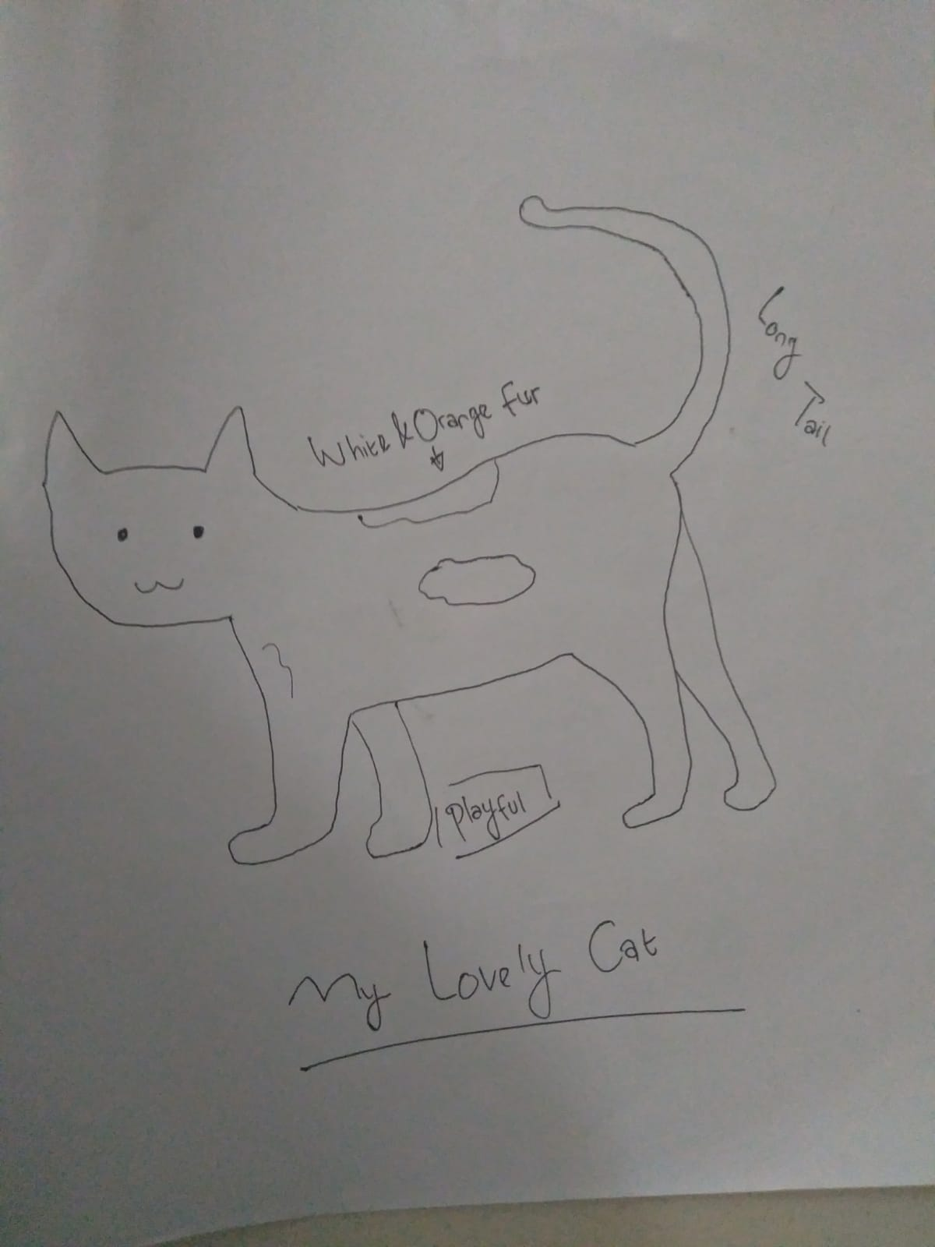

Text 1 :
A Lion
Lions have strong, compact bodies and powerful forelegs, teeth, and jaws for pulling down and killing prey. Their coats are yellow-gold. Adult males have shaggy manes that range in colour from blond to reddish-brown to black and also vary in length.
Adapted from: https://asaljeplak.com/kamusinggris/literatur/contoh-descriptive-text-hewan-singa/

Text 2 :
Giant Panda
Pandas are bear-like animal which originally live in centre and western part of China. Pandas have distinguished features that make them different other species of bear. Pandas have white thick fur which covers all of their body with black eyes patches, ears, nose, legs, shoulders, and arms. Those black marks make Pandas unique and different. Like other species of bear, pandas have a big head, a short tail, rounded ears, and a long muzzle with a big nose. However, pandas’ diet is totally different with other species of bear; in which they prefer bamboos than others. 90% of pandas’ diet consists of bamboos. That is why pandas have adapted their body to help them in eating bamboos. Pandas have a big jaw with tough muscles and strong molars to crush bamboos so they can extract the nutrients they need.
Adapted from: https://www.kelaspintar.id/blog/edutech/melihat-contoh-descriptive-text-3258/

Text 3 :
My favourite Mug
I have a favourite mug. My mother gave it to me on my birthday last month. It is a white mug with my name written on it. And under my name is written the date of my birthday. It has a handle so I can use it to drink hot milk safely. I use it every day. Whatever I drink, I will use it. I really like my mug. I do not let other people using it.
Adapted from: https://www.jagoanbahasainggris.com/2018/11/7-contoh-descriptive-text-tentang-benda-kesayangan.html

Text 4 :
My Teddy Bear
I have a favorite doll. It is an original Teddy Bear from America. Aunt Lily gave it to me last year when she returned from her business trip in New York. I was very happy. I put it on a cabinet next to my bed. Sometimes I use it as a pillow.
My Teddy Bear is very big, and the colour is brown. It is about 150 centimeters tall and the width is about 50 centimeters. When I put it on my bed it will occupy half of it. It is almost as big as my body. It is made of typical kind of fabric called rasfur. The head is round with the size of 25 centimeters. It has two ears which located on top of its head. The shape of the ear is half circle and the size is half of my palm. The colour of its eye is dark brown. I think it is made of glass since I can see through it. It has a light brown ribbon encircling its neck. On the sole of each foot, there is a paw pattern made of smooth fabric.
Adapted from: https://www.jagoanbahasainggris.com/2018/11/7-contoh-descriptive-text-tentang-benda-kesayangan.html
Material :
Lusia is my classmate. She is very beautiful and friendly. Her hair is as long as her shoulders. She is very energetic. She is very active in her school and takes some extracurricular subjects. One of them is dancing.
She has been practicing dance since she was six years old. She can dance both traditional and modern dances, but she prefers traditional dances to modern ones. Her favourite dance is pakarena dance. It is from Makassar. Every time she performs the dance on the stage, she always gives her best performance to her audience so they really enjoy her dance.
So far, she has appeared many times in formal ceremonies so she is very famous in our school. She often performs abroad as a member of Indonesia cultural delegations. Someday, she dreams to become a well-known dancer and if she has enough money, she will own a dancing company.
Adapted from: https://www.sekolahbahasainggris.co.id/11-contoh-soal-descriptive-text-bahasa-inggris-untuk-smp/
Answer the following questions according to the text above!
  - What is the main idea of the third paragraph?
  - Why does the audience like her performance?
  - “Every time she performs the dance on the stage, she always gives her best performance to her audience so they really enjoy her dance.”
What does they refer to? See the last sentences of the second paragraph.
  - What is a good title of the text above?
  - “She often performs abroad as a member of Indonesia cultural delegations.”
The antonym of the word “often” is?
APPENDIX 2: LESSON PLAN 2

Name : I Gede Sandi Yasa
Education level : Junior High School
Subject : English
Class/Semester : VIII
Material : Inviting Someone
Time : 1x45 minutes

    - Core Competencies:
KI 1: To respect and to comprehend their own beliefs.
KI 2: To respect and to comprehend honest, discipline, responsible, and caring behaviour (tolerance, mutual cooperation), well-behaved, confident, in interacting effectively with the social interaction and natural environment in the society and its existence.
KI 3: To understand and apply the knowledge (factual, conceptual, and procedural) based on his curiosity about science, technology, arts, culture, and events related to phenomena seemed by eyes.
KI 4: To rework, present, and give a reason in the realm of concrete (using, parsing, composing, modifying, and creating) and the realm of the abstract (writing, reading, counting, drawing, and fabricated) according to the learned in schools and other sources in the same point of view/theory.
    - Basic Competencies and Indicator
No. | Basic competencies | Indicator
3. | - To apply the generic structure and language features to carry out the social function of spoken and written interpersonal interaction texts involving the act of inviting someone, and responding to it, according to the context of its use. | - To identify generic structure, social functions, and language features of invitation texts/dialog.
4. | - To catch the contextual meaning related to social functions, generic structure, and language features of interpersonal interaction text that involves the act of inviting someone and responding to it | - To get information from written invitation texts/dialog in the form of a short and simple.  - To show the results of the discussion with the group regarding the order of written Invitation texts.  - To illustrate simple written interpersonal interaction texts involving the act of inviting someone.

    - Learning Objectives: :
    - Students are able to identify generic structure, social functions, and language features of written interpersonal interaction texts involving the act of inviting someone and responding to them correctly.
    - Students are able to mention detail information in the invitation text correctly.
    - Students are able to illustrate the invitation card from written text correctly.

    - Material
    - Social function:
- It is to invite someone, attend/come an event.
    - Generic structure:
- Receiver/To: nama orang yang dituju/yang diundang
- Body of invitation/isi undangan: Isi undangan biasanya berupa hal hal berikut ini:
Subjek: Nama Acara
Day or Date: Hari dan tanggal
Time: Waktu yang ditetapkan
Place: Tempat dimana acara tersebut diadakan
- Sender/from: Orang yang mengirim undangan
    - Language features:
- Use simple present tense

    - M edia, Tools, and Learning Resources
Media : Picture, LCD, and Laptop
Learning Resources : Internet, other relevant sources

    - Learning Activities
    - Pre-activities
1. The teacher prepares students psychologically and physically for the learning process
2. The teacher asks questions about the relationship between previous knowledge and the material to be studied.
3. The teacher explains the learning objectives or basic competencies to be achieved

    - Whilst activities
- The students listen to the teacher’s explanation about the definition, the purpose, the generic structure and the example from the material.
- The students are asked to read the text or create or search his own text/dialog (the students can choose the different text).
- The students are asked to visualize and create the pictures from the invitation text/dialog (simple sketch is acceptable).
- The students are asked to answer the questions from the text.
- The students submit the answer and the sketches (can be in google classroom).

- Post activities
  - The teacher asks students to make conclusions about the material that has been studied.
  - The teacher reflects on the course of the learning process that day.
  - The teacher closes the class while greeting the students.

Dialog Example
Yulius: What is your planning tonight?
(Apa rencanamu malam ini?)
Sarah: I am still thinking it over, what’s the matter?
(Aku masih memikirkannya, ada apa?)
Yulius: I would like to invite you to have dinner in Jeon steak and burger around seven.
(Aku ingin mengundangmu untuk makan malam di Jeon steak and burger sekitar pukul tujuh)
Sarah: It sounds great. Can you pick me up?
(Kedengarannya bagus. Dapatkah kamu menjemputku?)
Yulius: Never mind, I will ride my motorcycle to your home
(Tidak apa-apa, aku akan mengendarai motorku ke rumahmu)
Sarah: Thank you very much
(Terima kasih banyak)

Birthday Invitation Example
To: Paijo
I invite you to attend 16th my birthday party. It will be held:
Day/Date: Sunday/ 13 August 2021
Time: 03.00 p.m.
Place: at my sweet house (Prapatan Street number 16)
I hope your coming
Mawar
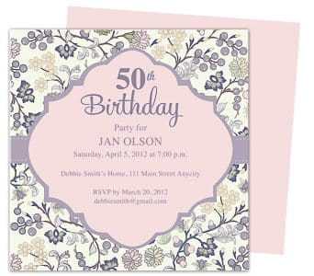

STUDENT ORGANIZATION
SMP. Negeri 1
JL Soekarno Hatta 15/26
Telp (021) 4244612
Dear Sabarina
We invite you to attend our meeting that will be held:
On Saturday, August 8,2077
At 01.30 p.m. – 02.30 p.m.
In the school hall
Agenda= final preparation for the 2015 PENSI competition please come on time, see your there.

Nazmi,  Secretary | Farhan,  Chair Person
Answer the following questions according to the text above!
  - When is the meeting will be held?
  - What is the purpose of the text?
  - What is the text about?
  - “We invite you to attend our meeting that will be held”
What is the antonym of the underlined word?
  - Who is Nazmi?

APPENDIX 3: LESSON PLAN 3

Name : I Gede Sandi Yasa
Education level : Junior High School
Subject : English
Class/Semester : VIII
Material : Recount Text
Time : 1x45 minutes

- Core Competencies:
KI 1: To respect and to comprehend their own beliefs.
KI 2: To respect and to comprehend honest, discipline, responsible, and caring behaviour (tolerance, mutual cooperation), well-behaved, confident, in interacting effectively with the social interaction and natural environment in the society and its existence.
KI 3: To understand and apply the knowledge (factual, conceptual, and procedural) based on his curiosity about science, technology, arts, culture, and events related to phenomena seemed by eyes.
KI 4: To rework, present, and give a reason in the realm of concrete (using, parsing, composing, modifying, and creating) and the realm of the abstract (writing, reading, counting, drawing, and fabricated) according to the learned in schools and other sources in the same point of view/theory.
- Basic Competencies and Indicator
No. | Basic competencies | Indicator
3. | - To compare social functions, generic structure, and language features of several oral and written personal recount texts by giving and asking for information related to personal experiences in the past, short and simple, according to the context of their use. | - To identify generic structure, social functions, and language features of recount text.
4. | 4.1 To catch the contextual meaning related to social functions, generic structure, and language features of oral and written recount texts, short and simple, related to personal experiences in the past (personal recount). | - To get information from written recount text in the form of a short and simple related to personal experiences in the past (personal recount).  - To show the results of the discussion with the group regarding the order of written personal recount texts related to personal experiences in the past, short and simple.  - To illustrate the story of written personal recount texts related to personal experiences in the past, short and simple.

- Learning Objectives: :
        - Students are able to identify generic structure, social functions, and language features of recount text correctly.
        - Students are able to mention main ideas and other detail information in recount text correctly.
        - Students are able to illustrate the story from written recount text properly.

- Material
- Social function:
- To retell events for the purpose of informing or entertaining
- Generic structure:
- Orientation: Introducing the participants, place and time
- Events: Describing series of event that happened in the past
- Reorientation: It is optional. Stating personal comment of the writer to the story
- Language features:
- Introducing personal participant; I, my group, etc.
- Using chronological connection; then, first, etc.
- Using linking verb; was, were, saw, heard, etc.
- Using action verb; look, go, change, etc.
- Using simple past tense

- M edia, Tools, and Learning Resources
Media : Picture, LCD, and Laptop
Learning Resources : Internet, other relevant sources

- Learning Activities
  - Pre-activities
1. The teacher prepares students psychologically and physically for the learning process
2. The teacher asks questions about the relationship between previous knowledge and the material to be studied.
3. The teacher explains the learning objectives or basic competencies to be achieved

  - Whilst activities
- The students listen to the teacher’s explanation about the definition, the purpose, the generic structure and the example of recount text.
- The students listen to the teacher demonstrates the strategy by reading the text “Holiday in Lembah Pelangi Waterfall” to the students.
- The students are asked to reads the text entitled “Visiting Way Kambas”
- The students are asked the students to visualize and create pictures.
- The students share their sketches and the teacher points out individual differences.
- The teacher asks the students to actively discussing the main ideas, certain information, and detailed information from answer the questions from the text.
- The students submit reports from the results of discussions in discussing generic structures, language features, main ideas, certain information, and detailed information from narrative text.

  - Post activities
  - The teacher asks students to make conclusions about the material that has been studied.
  - The teacher reflects on the course of the learning process that day.
  - The teacher closes the class while greeting the students.

Material :
Holiday in Lembah Pelangi Waterfall
Last holiday, I and my beloved wife, visited Lembah Pelangi Waterfall in Ngarip District, Tanggamus Regency, Lampung Province, Indonesia. It was the first time for me to visit such a wonderful waterfall.
To reach the waterfall location, we should go on foot after having around three hours trip riding a motorcycle from Bandar Lampung, the capital city of Lampung. When we arrived there, I was amazed by the beautiful scenery of the waterfall. The air was so fresh at that time and I could not bear to jump into the water immediately. It is quite windy there and all I could see only green, green, and green. Hearing the sound of falling water while we were swimming made me feel peaceful and relaxing.
Finally, the day was getting dark and it was time for us to go home. It was such an unforgettable experience for me. I really enjoyed it.
Adapted from: https://www.englishiana.com/2016/03/10-contoh-recount-text-holiday-dan.html

Sketches Example :
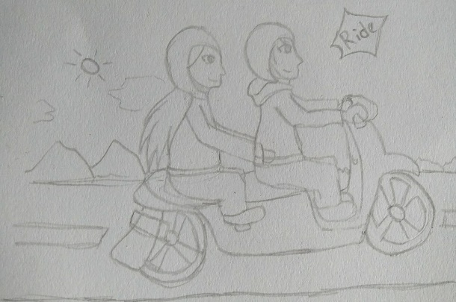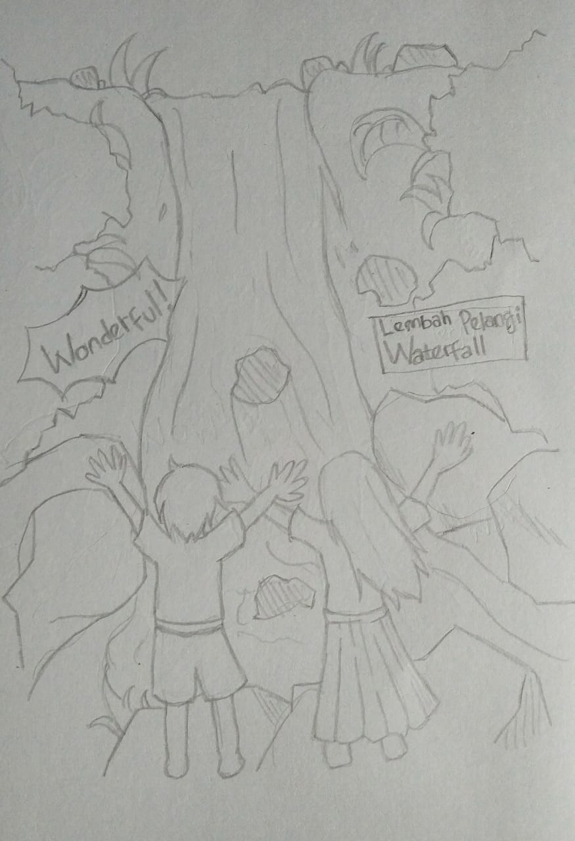
Sketch 1 Sketch 2
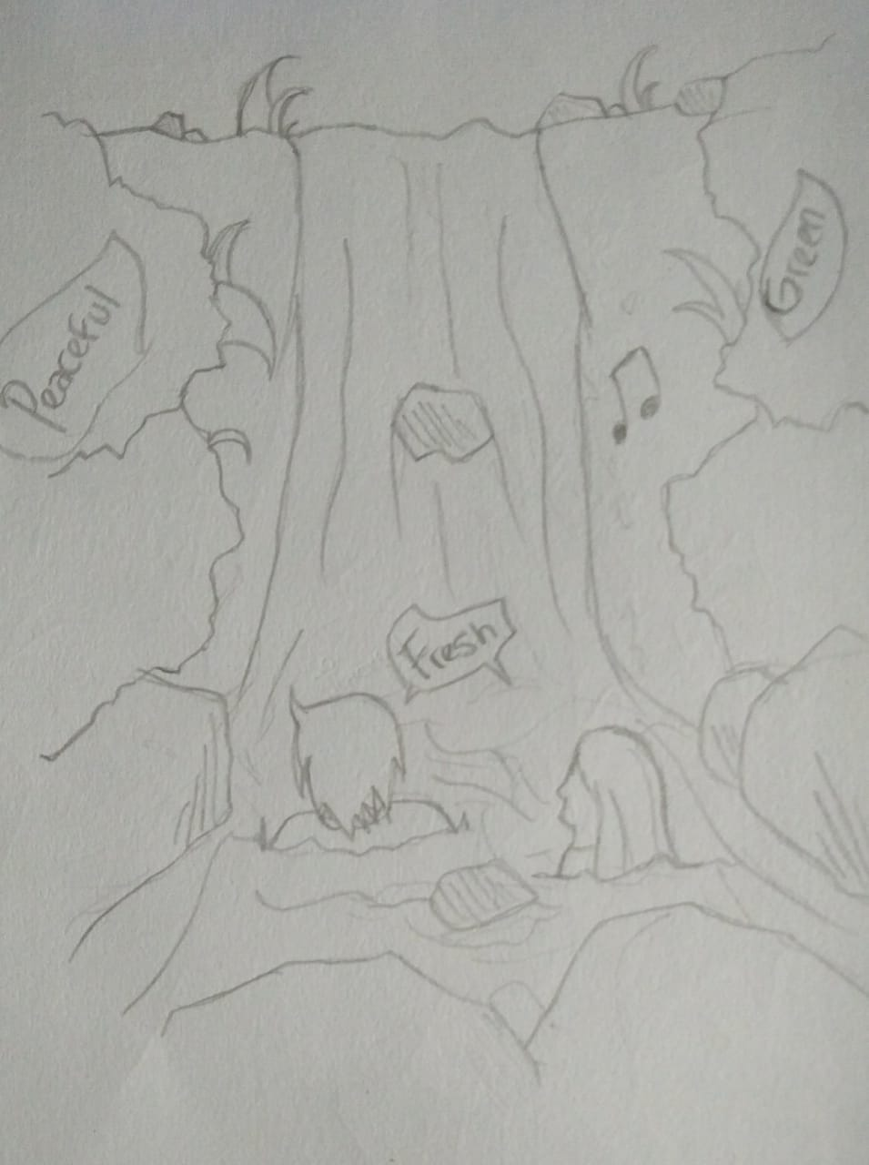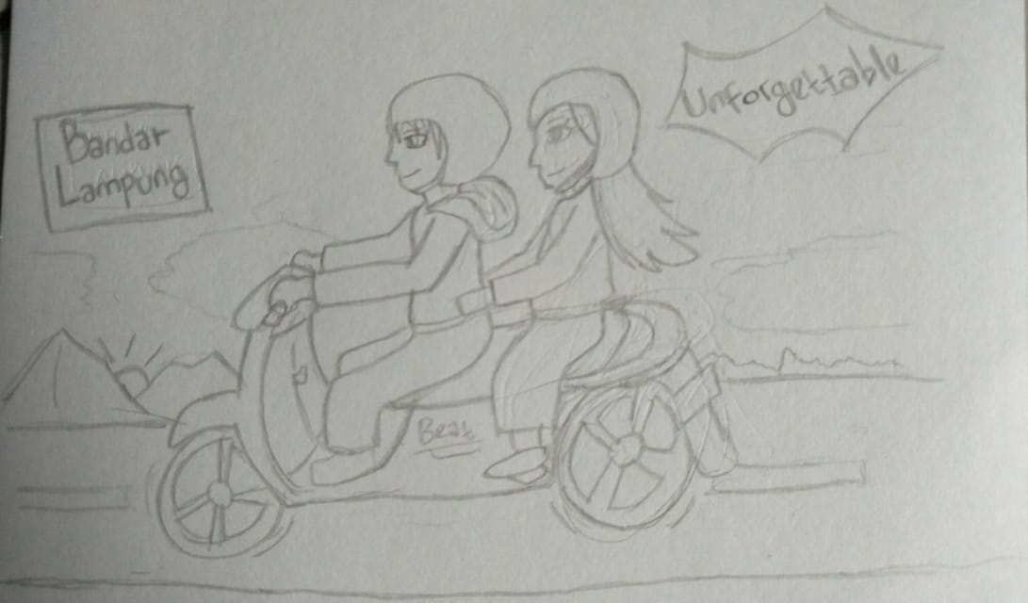
Sketch 3 Sketch 4

Task 1
Read and sketch the story based on the text below!

Visiting Way Kambas
Yesterday I and my family went to Way Kambas national park to see the elephants and rhinos conserved there. Way Kambas National Park is a national park which is used as elephant and rhino sanctuary located in Labuhan Ratu District, East Lampung, Lampung, Indonesia
When we got to there, we saw some elephant performances such as playing football, sitting, greeting the visitors, and other entertaining performances. Unfortunately, we could not see the Sumatran rhinoceros because visitors must have a special permit in advance to see them. Visitors or ordinary tourists cannot see the Sumatran rhino’s natural breeding. In the afternoon we saw some animals which were being fed.
When we returned home, we were tired but we were happy because we had so much fun in Way Kambas.
Adapted from: https://www.englishiana.com/2016/03/10-contoh-recount-text-holiday-dan.html

Task 2
Answer the following questions according to the text above!
    - What is the purpose of the text?
    - “Unfortunately, we could not see the Sumatran rhinoceros because visitors must have a special permit in advance to see them.”
What is the antonym of the word “unfortunately”?
  - Why they cannot see the Sumatran rhinoceros?
  - “Unfortunately, we could not see the Sumatran rhinoceros because visitors must have a special permit in advance to see them.”
What does the word “them” refer to?
  - What elephant performance did they see at Way Kambas?

APPENDIX 4: Table Specification of Try-Out Test
No | The Types of Reading Comprehension | Items Numbers | Percentage
1. | Determining main idea | 5, 10, 17, 19, 22, 26, 31, 40, 44, 49  32,40 | 20 %
2. | Finding specific information | 2, 7, 15, 20, 23, 25, 28, 35, 46, 50  26,29,33,34,36,37 | 20 %
3. | Finding references | 4, 9, 12, 16, 24, 27, 33, 39, 42, 47 | 20 %
4. | Understanding vocabulary | 1, 6, 11, 14, 29, 34, 38, 43, 45, 48 | 20 %
5. | Inference | 3, 8, 13, 18, 21, 30, 32, 36, 37, 41 | 20 %
Total |  | 50 | 100 %

APPENDIX 5: Reading Comprehension Test (Try out)
Choose the best answer by crossing (X) a, b, c, or d on the answer sheet.

TEXT 1 (Questions 1 – 4)
In the Sunny Day
Last weekend, my family and I went to Rongkang beach near our grandparents’ house. The day was sunny and hot, of course. It was on June. That’s why the day was very bright. In our country, Indonesia, there are two seasons. They are dry season and rainy season. The dry season starts from May and lasts for 5 months. While, rainy season starts from November and ends in March. The view was so beautiful. There were many people at the beach. Most of them were teenagers.
We were having fun. We built a sandcastle. We had to rebuild twice before it really stood up. The first attempt failed because we built it too close to the water. And the second attempt, the successful one, was just right. The spot we chose was not too close to the water and the mixture was good.
Our parents loved our work. Some people who passed our castle loved it, too. They even took pictures near our castle. We were so proud of our work that day.
Adapted from: http://whywine.wordpress.com/2010/05/05/contoh-recount-text/

    - What is the purpose of the text above?
a. It describes the Rongkang beach.
b. It tells the reader about the past experience of the writer in the Rongkang beach.
c. It tells the reader about the writer’s daily activities in the Rongkang beach.
d. It gives some information about Rongkang beach to the reader.

    - The main idea of the text is ...
a. The writer and family went to Rongkang beach a week ago.
b. The writer and family stayed in Rongkang beach for a week.
c. The writer and family sold a sandcastle in Rongkang beach.
d. The writer and family went to Rongkang beach by a pedicab

    - What did the people do near the sandcastle?
a. They built a sandcastle.
b. They took pictures.
c. They ate food.
d. They sold shoes.

    - “They even took pictures near our castle.”
What does the word “they” in line 11 refers to?
a. The writer and friend.
b. The children.
c. The people who passed.
d. The writer’ family.
TEXT 3 (Questions 5 – 10)
A GREEDY ANGEL
Once upon the time, there was an angel who was cursed by the God to be an ugly giant and was sent to a heavy forest. Feeling so sad about her body, she always cried while she was sitting on a big rock under elm three. She did not want to eat anything. She only had one wish that was she wanted to be beautiful as before. Then, a fairy mother came approaching her.
“Hi, ugly giant. Why do you look so sad?” asked the fairy mother.
“I want to be a beautiful angel. Once I was an angel, but I did something wrong. So, God changed me into an ugly giant. That makes me so sad,”
the ugly giant answered.
“Well”, I’ll help you. Look at this jewel, follow its light. Next, you will arrive at a pond. You must dive yourself in that pond for five times. Then, you will change into a beautiful angel,” said the fairy, holding a bright jewel.
The fairy mother then disappeared, while the jewel flew away into the air. The ugly giant walked fast following the jewel until she arrived at a pond. There, she dived herself five times into the water.
Amazing! She turned into a beautiful angel!
“Wow! If I dive five more times again, I must turn to be more beautiful,” she said.
Thus, she dived again for another five times, and she turned back into an ugly giant! That’s because of her greediness.
Taken from: Fantastic Stories from the Dreamland; Comprehensive Reading for Young Learners

  - The text is mainly about …
a. An angel who blessed by the God.
b. An angel who was cursed by the God.
c. An angel was given a jewel from the God.
d. An angel who got the power from the God.

  - “Then, a fairy mother came approaching her.” (paragraph 1) The underlined word refers to …
a. Ugly giant
b. Fairy mother
c. Jewel
d. Beautiful angel

  - The giant did not want to eat anything because …
a. She was so sad about her body.
b. She wanted to sit under the elm tree.
c. She wanted to meet a fairy mother.
d. She wanted to have the jewel.

  - Which is the moral value of the text?
a. Don’t make any wrong.
b. Don’t draw false conclusion.
c. Don’t be greedy.
d. Don’t believe in doubted idea.

  - “…She dived again for another five times...”
The underlined word refers to…
a. The Fairy Mother
b. The greedy angel
c. The bright jewel
d. The Angel

  - What is the main idea from the first paragraph?
a. The ugly giant meets the fairy mother
b. The ugly giant dive at a pond for five times
c. There was an angel who was cursed by the God to be an ugly giant
d. The angel turns back into the ugly giant.

TEXT 4 (Questions 11 – 14)
My Brother
Sandy is the youngest in our family. He is fourteen years old and four years younger than me. He has long, straight hair, bright eyes and a friendly smile. Sometimes he is rather naughty at home, but he usually does what he is asked to do.
Sandy is interested in sports very much, and at school, he plays football and tennis. He is the best badminton player in our family.
(Adapted from: https://banksoal.belajar.kemdikbud.go.id/ )

  - “Sandy is interested in sports very much, and at school he plays football and tennis.”
The underlined phrase can be replaced by ….
a. Dislike sport
b. Really likes sport
c. Hates sport very much
d. Finds sport not entertaining

  - ” He is fourteen years old . . . Than me.”
The underlined word refers to ….
a. Sandy
b. The writer
c. The writer’s brother
d. The writer’s family.

  - From the text, we may conclude that….
a. Many people do not like Sandy.
b. People is older that the writer.
c. Sandy is a welcoming person.
d. Sandy is not diligent at all.

  - “Sometimes he is rather naughty at home…” The antonym of the underlined word is…
a. Kind
b. Behave
c. Cool
d. Tolerant
TEXT 5 (Questions 15 – 20)
A Trip to Jogjakarta
Last year, I spent my holiday in Jogjakarta. I went there by bus. My bus departed at seven o’clock sharp in the morning.
In the middle of the trip, the bus suddenly stopped. I felt afraid immediately. I thought about bad things that could happen on the street. Then I saw the driver’s assistant got off the bus. After he returned, he told me and the other passengers that there were a road accident and the police already handled it. However, my bus could go nowhere for a while. My bus was trapped in the queue for about three and a half hours.
I finally arrived at Giwangan Bus Station at dawn. It was the most tiring trip I ever had.
(Adapted from: http://whywine.wordpress.com/2010/05/05/contoh-recount-text/)

  - What happened to the bus?
a. It hit Giwangan Bus Station.
b. It collided with the other cars.
c. It got trapped in the road accident.
d. It ran out of gas.

  - “After he returned, he told me and...”
What does the word “he” in line 4 refers to?
a. The writer.
b. The driver’s assistant.
c. The police.
d. The reader.

  - What is the main idea of the text above?
a. The writer went to Jogjakarta by bus.
b. The writer saw the driver’s assistant went off the bus.
c. The writer was trapped in the queue for about three and a half hours.
d. The writer’s holiday in Jogjakarta was the most tiring trip.

  - The purpose of text is …
a. To describe something.
b. To retell something.
c. To instruct something.
d. To argue on something.

  - What is the topic of the text above?
a. Got trapped in the road accident.
b. My tiring trip.
c. Travelling by bus.
d. Car accident.

  - What did the police do in that road?
a. He spent my holiday.
b. He got off the bus.
c. He tried to handle the accident.
d. He queued for about three and a half hours.

TEXT 1 (Questions 21 – 24)

In Fairy Kingdom, lived Patrick the prince. He was very handsome and kind. One day, he saw a beautiful girl with wings coming towards him when he stood by the side of his father.
“Who are you and where are you from, lady? Asked Patrick. The strange girl smiled at the prince. “I come from the land of life.” She said, “Would you come with me?”
The king and his servant wondered much to hear a voice when they saw no one. Patrick kept talking with the girl though all the people with him did not see her. “The prince must be under the magic spell. Hurry up! Call Dameon to help him!” said the king. Dameon the healer then came with a wand. He chanted his spells towards the prince, then the girl’s voice disappeared. But before the girl vanished, she threw an apple to Patrick. The apple was seized by the king from Patrick’s hand.
A month went by, none heard the girl’s voice again. But Patrick the prince was ill from the day he saw the girl. For a whole month he ate nothing. No doctors and healers could cure him. “Ask the prince to eat the apple I have.” Suddenly the girl’s voice was heard very loud. The king then called Dameon for the second time. “No need, king. The prince will soon get well by eating my apple.” said the lady. The lady held Patrick’s hand and smiled. Meanwhile, the king still saw no one. “Alright, my son. Eat this apple.” The king gave the apple to Patrick. Shortly after Patrick ate it, he recovered from his illness.
“Now, give me a chance to look your appearance, Lady. I beg you, please.” said the king. Then, a beautiful girl emerged from nowhere, holding the prince’s hand. “Come with me Prince, we can live together in the land of life.” said the girl. She then covered Patrick with her wings and rushed away from them the gleaming crystal. The king saw it glide away to the sun. Away and away until eye could see it no longer, and Patrick and the girl never came back again.
Adapted from Fantastic Stories from the Dreamland

    - “He chanted his spells towards the prince …” (paragraph 3) The closest meaning of the underlined word is …
a. Murmur
b. Cast
c. Yield
d. Whisper

    - If the prince ate the apple …
a. The lady would not disappear.
b. The king would see the lady.
c. Dameon would not come.
d. The prince would not get sick.

    - What is happened to the prince?
a. The prince going crazy.
b. The prince gets married with the angel
c. The prince lives together with the angel
d. The apple makes the prince life

    - “Now, give me a chance to look your appearance, …” (paragraph 6) The underlined word refers to …
a. The lady.
b. The prince.
c. The king.
d. Dameon.

TEXT 2 (Questions 25 – 29)
One day there was a monkey. He wanted to cross a river. There he saw a crocodile so he asked the crocodile to take him across the other side of the river. The crocodile agrees and told the monkey to jump on its back. Then the crocodile swam down the river with the monkey on his top.
Unluckily, the crocodile was very hungry, he stopped in the middle of the river and said to the monkey, “My father is very sick. He has to eat the heart of the monkey. So, he will be healthy again.” At the time, the monkey was in dangerous situation and he had to think hard. Then he had a good idea. He told the crocodile to swim back to the river bank.
“What’s for?” asked the crocodile.
“Because I don’t bring my heart,” said the monkey.
“I left it under a tree, near some coconuts in the river bank”. The crocodile agreed and turned around.
He swam back to the bank of the river. As soon as they reached the river bank, the monkey jumped off the crocodile’s back. Then he climbed up to the top of a tree.
“Where is your heart?” asked the crocodile.
“You are foolish,” said the monkey to the crocodile.
“Now I am free and I have my heart.”
Taken from: https://www.ilmubahasainggris.com/narrative-text-bahasa-inggris-berjudul-monkey-and-crocodile-lengkap-dengan-pembahasan-generic-structure/

  - The monkey asked help to the crocodile because …
a. He wanted to cross the river
b. He wanted to fool the crocodile.
c. He wanted to help the crocodile.
d. He wanted to jump onto the crocodile.

  - What is the main idea of the second (2nd) paragraph?
a. The monkey felt hungry.
b. The crocodile lied to the monkey.
c. The crocodile’s father was sick.
d. The crocodile ate monkey’s heart

  - “He has to eat the heart of the monkey”
What does the word “he” refers to?
a. The crocodile son.
b. The monkey.
c. The monkey heart.
d. The crocodile father.

  - If the crocodile was not lying to the monkey…
a. The monkey would not trick him.
b. The monkey would give his heart.
c. The monkey would not jump onto his back.
d. The monkey would not ask him to the river.

  - “Unluckily, the crocodile was very hungry”
The opposite of “Unluckily” is?
a. Unfortunate
b. Luckless
c. Lucky
d. Cursed

TEXT 3 (Questions 30 – 36)
Once there lived a beautiful princess in a big castle. She wanted to marry a real prince, who could be a generous king in the future. There were many handsome and rich princes, but it was very difficult to find the real one. She had asked her servants to travel all over the world to find it, but nowhere could they get what the princess wanted.
Once shiny morning, suddenly the princess heard someone knocking at the gate. The old king went to open it. The beautiful princess was standing anxiously in front of her castle. Out of there, in front of the gate, she saw a very handsome prince who looked very thirsty. His face was full of sweat and seemed to be so tired.
“Come in, we will serve you a plenty of meal and a comfortable bed.” said the old king.
“No, thanks. Just give me a drink. I’m very thirsty.”
The prince was led into the castle. The princess then gave him ten cups of tea. But, in the kitchen, she had mixed the tea with tasteless but dirty water. There was only one cup which was the pure tea.
“Ah, very badly!” said the prince after he smelled the drink one by one. “You gave me dirty tea! But I will drink one.”
The prince took a cup of tea which was not mixed with dirty water, and then drank it.
Now, the princess and the old king knew that he was a real prince for he could know the pure tea between the nine cups of dirty tea. It meant that the prince could be a kind king, because he was so sensitive, that he would run the castle generously and could feel his people’s sadness. So, the princess took him or her husband and asked him to be the king.
Adapted from Fantastic Stories from the Dreamland

  - What kind of prince did the princess want to marry with?
a. Handsome
b. Rich
c. Big
d. Generous

- What is the best title for the story above?
a. The Real Prince
b. The Generous Prince
c. The Smart Prince
d. The Sensitive Prince

- “… He would run the castle generously ….” (Paragraph 8) The underlined word above refers to …
a. The princess
b. The prince
c. The old king
d. The servant

- What can we conclude from the story?
a. A princess tried to fool the prince.
b. A princess wanted to find a rich prince.
c. A real prince is someone who is sensitive.
d. A prince tried hard to find the real princess.

- “But, in the kitchen, she had mixed the tea with tasteless but dirty water” (paragraph 3) The synonym of the underlined word is …
a. Soiled
b. Muddy
c. Dirt
d. Cheap

- Which statement is FALSE about the story?
a. The prince asked for drink.
b. Most of the cups of tea were dirty tea.
c. The old king served plenty meal.
d. The princess took him as her husband.

- The princess took the prince as the king because …
a. The princess wanted to know him more.
b. The prince was sensitive.
c. The prince was not greedy.
d. The princess liked him.

TEXT 4 (Questions 37 – 41)
My Personal Experience
When I was in junior high school, I was not a very diligent student. In fact, I was quite lazy. I hated all the subjects that I took during school, especially science. For me, science was very difficult. It was hard for me to remember the chemical process, physics calculations, and biological processes.
Once, my teacher grounded me in the library because I did not do my Biology homework. The teacher asked me to read several books and make a summary about them. When I was browsing the shelves, I found a book entitled “The Inventors of Medicine”. I thought “OK, this is a start”. I took it out then began reading it.
I learned from the book about Edward Jenner. He was an English doctor who found the cure of smallpox. The next one was Louis Pasteur. His interest in bacteria led him to discover the treatments for rabies and anthrax. Just like Pasteur, Robert Koch’s experiments on bacteria also proved that tuberculosis can be spread to others by contact. Finally, there was Alexander Flemming, a British bacteriologist who found the first antibiotic and penicillin.
After I read the book, I realized that science is useful for human kind. By studying, we can discover things that can help human kind. Therefore, since that moment, I managed to change my behaviour and became a doctor.
Taken from English in Focus VIII

- Why did the writer read the books in the library?
a. He hated all subjects.
b. He did not do his homework.
c. He liked reading the books.
d. He could not remember chemical process.

- “Once, my teacher grounded me in the library ....” (paragraph 2) The synonym of the underlined word is …
a. Caused
b. Locked
c. Punished
d. Arrested

- “It was hard for me to remember the chemical process, physics calculations, and biological processes”
The word “it” refers to…
a. The teacher
b. Science
c. The writer
d. Book

- The main idea of the second paragraph is…
a. The writer get punishment to make a summary.
b. The writer realize science is useful for human kind.
c. The writer starts learned from the book
d. The writer starts to change his behaviour.

- The writer started to manage his behaviour because …
a. He grounded in the library to make a summary.
b. He realized that science is useful for human kind.
c. He wanted to discover medicine for human kind.
d. He wanted to be one of the inventors of medicine.
TEXT 5 (Questions 42 – 45)
Ice Hockey
Ice hockey, by birth and upbringing a Canadian game, is an offshoot of field hockey. Some historians say that the first ice hockey game was in Montreal in December 1879 between two teams composed almost exclusively of McGill University students. But others believe that earlier hockey games took place in Kingston, Ontario, or Halifax, Nova Scotia. In the Montreal Game of 1879, there were 15 players on a side. The players used an assortment of sticks to keep the puck in motion. Early rules allowed nine men on a side, but the number was reduced to seven in 1886 and later to six. In the winter of 1894 – 1895, a group of college students from the United States visited Canada and saw hockey played. Enthusiastic about the game, they introduced it as a winter sport when they returned home.
Taken from: Interactive English for Junior High School Grade VIII

- What is “stick”?
a. A long thin piece of wood with a curved end used in playing ice hockey.
b. A strong hard hat that covers and protects the head.
c. A small hard rubber disc which is used instead of a ball in ice hockey.
d. A particular set of clothes which has to be worn by players in ice hockey

- Where did a group of students from United States introduce ice hockey as a winter sport game?
a. Canada
b. Montreal
c. Kingston
d. United States

- What is the main idea of the text?
a. The first ice hockey
b. The Canadian game
c. A winter sport
d. The history of the ice hockey

- “Early rules allowed nine men on a side, but the number was reduced to seven in 1886 and later to six”
The antonym of the underlined word is…
a. Soon
b. Late
c. Quick
d. In time

TEXT 6 (Questions 46 – 50)
A Journey to Bali
Last holiday after national examination, I went to Bali for 4 days with my family. My father and my mother went to Bali for 3 days before my brother and I were there. In Bali, we went to many places. On first day, after my brother and I arrived in Ngurah Rai airport, we went to Sanur beach, Kuta beach, and Ulluwatu for watching Kecak dance. On second day, we went to Garuda Wisnu Kencana, Tanah Lot, and ate seafood in Jimbaran. Tanah lot was very beautiful. On the third day, we went to waterboom, Kuta beach, and art market to buy handicraft for my classmate. In last day, we just stayed in hotel and went to
Airport in the afternoon and arrived in Bandung in the evening. That was an amazing holiday!
Adapted from: http://afin.smpbustanulmakmur.sch.id/its-all-about-english/english-articles/recount-text

- How long did the writer stay in Bali?
a. Three days.
b. Two days.
c. Four days.
d. Seven days.

- “...watching Kecak dance.”
The underlined word has the following meaning, EXCEPT…
a. Observing.
b. Seeing.
c. Looking.
d. Took place.

- “… Before my brother and I were there...”
The underlined word refers to …
a. Uluwatu.
b. Bali.
c. GWK.
d. Jimbaran.

- What is the main idea of the text above?
a. The writer got an amazing holiday in Bali.
b. The writer saw Kecak dance with family.
c. The writer stayed in hotel of Bali.
d. The writer’s holiday in Bali was bad.

- What did the family do in Jimbaran?
a. They spent holiday.
b. They ate seafood.
c. They visited an art market.
d. They enjoyed in a waterboom.

APPENDIX 6: Table Specification of Pre-Test and Post-Test
No | The Types of Reading Comprehension | Items Numbers | Percentage
1. | Determining main idea | 2, 6, 11, 20, 24, 29  32,40 | 20 %
2. | Finding specific information | 3, 5, 8, 15, 26, 30  26,29,33,34,36,37 | 20 %
3. | Finding references | 4, 7, 13, 19, 22, 27 | 20 %
4. | Understanding vocabulary | 9, 14, 18, 23, 25, 28 | 20 %
5. | Inference | 1, 10, 12, 16, 17, 21 | 20 %
Total |  | 30 | 100 %

APPENDIX 7: Reading Comprehension Test (Pre-test/Post-test)
Choose the best answer by crossing (X) a, b, c, d on the answer sheet.
TEXT 1 (Questions 1 – 4)
In the Sunny Day
Last weekend, my family and I went to Rongkang beach near our grandparents’ house. The day was sunny and hot, of course. It was on June. That’s why the day was very bright. In our country, Indonesia, there are two seasons. They are dry season and rainy season. The dry season starts from May and lasts for 5 months. While, rainy season starts from November and ends in March. The view was so beautiful. There were many people at the beach. Most of them were teenagers.
We were having fun. We built a sandcastle. We had to rebuild twice before it really stood up. The first attempt failed because we built it too close to the water. And the second attempt, the successful one, was just right. The spot we chose was not too close to the water and the mixture was good.
Our parents loved our work. Some people who passed our castle loved it, too. They even took pictures near our castle. We were so proud of our work that day.
Adapted from: http://whywine.wordpress.com/2010/05/05/contoh-recount-text/

    - What is the purpose of the text above?
a. It describes the Rongkang beach.
b. It tells the reader about the past experience of the writer in the Rongkang beach.
c. It tells the reader about the writer’s daily activities in the Rongkang beach.
d. It gives some information about Rongkang beach to the reader.

    - The main idea of the text is ...
a. The writer and family went to Rongkang beach a week ago.
b. The writer and family stayed in Rongkang beach for a week.
c. The writer and family sold a sandcastle in Rongkang beach.
d. The writer and family went to Rongkang beach by a pedicab

    - What did the people do near the sandcastle?
a. They built a sandcastle.
b. They took pictures.
c. They ate food.
d. They sold shoes.

    - “They even took pictures near our castle.”
What does the word “they” in line 11 refers to?
a. The writer and friend.
b. The children.
c. The people who passed.
d. The writer’ family.
TEXT 2 (Questions 5 – 9)
One day there was a monkey. He wanted to cross a river. There he saw a crocodile so he asked the crocodile to take him across the other side of the river. The crocodile agrees and told the monkey to jump on its back. Then the crocodile swam down the river with the monkey on his top.
Unluckily, the crocodile was very hungry, he stopped in the middle of the river and said to the monkey, “My father is very sick. He has to eat the heart of the monkey. So, he will be healthy again.” At the time, the monkey was in dangerous situation and he had to think hard. Then he had a good idea. He told the crocodile to swim back to the river bank.
“What’s for?” asked the crocodile.
“Because I don’t bring my heart,” said the monkey.
“I left it under a tree, near some coconuts in the river bank”. The crocodile agreed and turned around.
He swam back to the bank of the river. As soon as they reached the river bank, the monkey jumped off the crocodile’s back. Then he climbed up to the top of a tree.
“Where is your heart?” asked the crocodile.
“You are foolish,” said the monkey to the crocodile.
“Now I am free and I have my heart.”

Taken from: https://www.ilmubahasainggris.com/narrative-text-bahasa-inggris-berjudul-monkey-and-crocodile-lengkap-dengan-pembahasan-generic-structure/

  - The monkey asked help to the crocodile because …
a. He wanted to cross the river
b. He wanted to fool the crocodile.
c. He wanted to help the crocodile.
d. He wanted to jump onto the crocodile.

  - What is the main idea of the second (2nd) paragraph?
a. The monkey felt hungry.
b. The crocodile lied to the monkey.
c. The crocodile’s father was sick.
d. The crocodile ate monkey’s heart

  - “He has to eat the heart of the monkey”
What does the word “he” refers to?
a. The crocodile son.
b. The monkey.
c. The monkey heart.
d. The crocodile father.

  - If the crocodile was not lying to the monkey…
a. The monkey would not trick him.
b. The monkey would give his heart.
c. The monkey would not jump onto his back.
d. The monkey would not ask him to the river.

  - “Unluckily, the crocodile was very hungry”
The opposite of “Unluckily” is?
a. Unfortunate
b. Luckless
c. Lucky
d. Cursed

TEXT 3 (Questions 10 – 16)
Once there lived a beautiful princess in a big castle. She wanted to marry a real prince, who could be a generous king in the future. There were many handsome and rich princes, but it was very difficult to find the real one. She had asked her servants to travel all over the world to find it, but nowhere could they get what the princess wanted.
Once shiny morning, suddenly the princess heard someone knocking at the gate. The old king went to open it. The beautiful princess was standing anxiously in front of her castle. Out of there, in front of the gate, she saw a very handsome prince who looked very thirsty. His face was full of sweat and seemed to be so tired.
“Come in, we will serve you a plenty of meal and a comfortable bed.” said the old king.
“No, thanks. Just give me a drink. I’m very thirsty.”
The prince was led into the castle. The princess then gave him ten cups of tea. But, in the kitchen, she had mixed the tea with tasteless but dirty water. There was only one cup which was the pure tea.
“Ah, very badly!” said the prince after he smelled the drink one by one. “You gave me dirty tea! But, I will drink one.”
The prince took a cup of tea which was not mixed with dirty water, and then drank it.
Now, the princess and the old king knew that he was a real prince for he could know the pure tea between the nine cups of dirty tea. It meant that the prince could be a kind king, because he was so sensitive, that he would run the castle generously and could feel his people’s sadness. So, the princess took him or her husband and asked him to be the king.
Adapted from Fantastic Stories from the Dreamland

  - What kind of prince did the princess want to marry with?
a. Handsome
b. Rich
c. Big
d. Generous

  - What is the best title for the story above?
a. The Real Prince
b. The Generous Prince
c. The Smart Prince
d. The Sensitive Prince

- “… He would run the castle generously ….” (Paragraph 8) The underlined word above refers to …
a. The princess
b. The prince
c. The old king
d. The servant

- What can we conclude from the story?
a. A princess tried to fool the prince.
b. A princess wanted to find a rich prince.
c. A real prince is someone who is sensitive.
d. A prince tried hard to find the real princess.

- “But, in the kitchen, she had mixed the tea with tasteless but dirty water” (paragraph 3) The synonym of the underlined word is …
a. Soiled
b. Muddy
c. Dirt
d. Cheap

- Which statement is FALSE about the story?
a. The prince asked for drink.
b. Most of the cups of tea were dirty tea.
c. The old king served plenty meal.
d. The princess took him as her husband.

- The princess took the prince as the king because …
a. The princess wanted to know him more.
b. The prince was sensitive.
c. The prince was not greedy.
d. The princess liked him.

TEXT 4 (Questions 17 – 21)
My Personal Experience
When I was in junior high school, I was not a very diligent student. In fact, I was quite lazy. I hated all the subjects that I took during school, especially science. For me, science was very difficult. It was hard for me to remember the chemical process, physics calculations, and biological processes.
Once, my teacher grounded me in the library because I did not do my Biology homework. The teacher asked me to read several books and make a summary about them. When I was browsing the shelves, I found a book entitled “The Inventors of Medicine”. I thought “OK, this is a start”. I took it out then began reading it.
I learned from the book about Edward Jenner. He was an English doctor who found the cure of smallpox. The next one was Louis Pasteur. His interest in bacteria led him to discover the treatments for rabies and anthrax. Just like Pasteur, Robert Koch’s experiments on bacteria also proved that tuberculosis can be spread to others by contact. Finally, there was Alexander Flemming, a British bacteriologist who found the first antibiotic and penicillin.
After I read the book, I realized that science is useful for human kind. By studying, we can discover things that can help human kind. Therefore, since that moment, I managed to change my behaviour and became a doctor.
Taken from English in Focus VIII

- Why did the writer read the books in the library?
a. He hated all subjects.
b. He did not do his homework.
c. He liked reading the books.
d. He could not remember chemical process.

- “Once, my teacher grounded me in the library ....” (paragraph 2) The synonym of the underlined word is …
a. Caused
b. Locked
c. Punished
d. Arrested

- “It was hard for me to remember the chemical process, physics calculations, and biological processes”
The word “it” refers to…
a. The teacher
b. Science
c. The writer
d. Book

- The main idea of the second paragraph is…
a. The writer get punishment to make a summary.
b. The writer realize science is useful for human kind.
c. The writer starts learned from the book
d. The writer starts to change his behaviour.

- The writer started to manage his behaviour because …
a. He grounded in the library to make a summary.
b. He realized that science is useful for human kind.
c. He wanted to discover medicine for human kind.
d. He wanted to be one of the inventors of medicine.

TEXT 5 (Questions 22 – 25)
Ice Hockey

Ice hockey, by birth and upbringing a Canadian game, is an offshoot of field hockey. Some historians say that the first ice hockey game was in Montreal in December 1879 between two teams composed almost exclusively of McGill University students. But others believe that earlier hockey games took place in Kingston, Ontario, or Halifax, Nova Scotia. In the Montreal Game of 1879, there were 15 players on a side. The players used an assortment of sticks to keep the puck in motion. Early rules allowed nine men on a side, but the number was reduced to seven in 1886 and later to six. In the winter of 1894 – 1895, a group of college students from the United States visited Canada and saw hockey played. Enthusiastic about the game, they introduced it as a winter sport when they returned home.
Taken from: Interactive English for Junior High School Grade VIII

- What is “stick”?
a. A long thin piece of wood with a curved end used in playing ice hockey.
b. A strong hard hat that covers and protects the head.
c. A small hard rubber disc which is used instead of a ball in ice hockey.
d. A particular set of clothes which has to be worn by players in ice hockey

- Where did a group of students from United States introduce ice hockey as a winter sport game?
a. Canada
b. Montreal
c. Kingston
d. United States

- What is the main idea of the text?
a. The first ice hockey
b. The Canadian game
c. A winter sport
d. The history of the ice hockey

- “Early rules allowed nine men on a side, but the number was reduced to seven in 1886 and later to six”
The antonym of the underlined word is…
a. Soon
b. Late
c. Quick
d. In time

TEXT 6 (Questions 26 – 30)
A Journey to Bali
Last holiday after national examination, I went to Bali for 4 days with my family. My father and my mother went to Bali for 3 days before my brother and I were there. In Bali, we went to many places. On first day, after my brother and I arrived in Ngurah Rai airport, we went to Sanur beach, Kuta beach, and Ulluwatu for watching Kecak dance. On second day, we went to Garuda Wisnu Kencana, Tanah Lot, and ate seafood in Jimbaran. Tanah lot was very beautiful. On the third day, we went to waterboom, Kuta beach, and art market to buy handicraft for my classmate. In last day, we just stayed in hotel and went to
Airport in the afternoon and arrived in Bandung in the evening. That was an amazing holiday!
Adapted from: http://afin.smpbustanulmakmur.sch.id/its-all-about-english/english-articles/recount-text

- How long did the writer stay in Bali?
a. Three days.
b. Two days.
c. Four days.
d. Seven days.

- “...watching Kecak dance.”
The underlined word has the following meaning, EXCEPT…
a. Observing.
b. Seeing.
c. Looking.
d. Took place.

- “… Before my brother and I were there...”
The underlined word refers to …
a. Uluwatu.
b. Bali.
c. GWK.
d. Jimbaran.

- What is the main idea of the text above?
a. The writer got an amazing holiday in Bali.
b. The writer saw Kecak dance with family.
c. The writer stayed in hotel of Bali.
d. The writer’s holiday in Bali was bad.

- What did the family do in Jimbaran?
a. They spent holiday.
b. They ate seafood.
c. They visited an art market.
d. They enjoyed in a waterboom.

APPENDIX 8: Questionnaire for the Students
Name :
Class :
Please fill the questionnaire based on your learning experience!

No. | Questions | Strongly Agree | Agree | Disagree | Strongly Disagree
1. | I Like to learn English using visualization strategy
2. | I am more motivated to learn English using visualization strategy
3. | Using visualization is a good learning strategy
4. | Using visualization strategy can help me to absorb the information easily
5. | Using visualization strategy can engage my interest to learn English deeper
6. | Using visualization can help me to understand the content of the text
7. | I collaborated with my friend in understanding the text
8. | Using visualization can help me to develop my imagination about the text
9. | Visualization strategy is suitable for learning reading comprehension
10. | Visualization is a kind of strategy that can help me understand English lesson
(Hastrianda, Hedwigis. 2018)

APPENDIX 9: Level of Difficulty and Discrimination Power of Try out test

Item | R | Upper | Lower | LD$=\frac{R}{N}$ | Criteria | DP$=\frac{U-L}{\frac{1}{2}N}$ | Criteria | Decision
1 | 17 | 7 | 2 | 0,56 | Average | 0,45 | Good | Administered
2 | 16 | 6 | 3 | 0,50 | Average | 0,40 | Satisfactory | Administered
3 | 15 | 5 | 3 | 0,47 | Average | 0,35 | Satisfactory | Administered
4 | 18 | 6 | 3 | 0,56 | Average | 0,40 | Satisfactory | Administered
5 | 18 | 6 | 2 | 0,56 | Average | 0,39 | Satisfactory | Administered
6 | 16 | 6 | 3 | 0,50 | Average | 0,38 | Satisfactory | Administered
7 | 17 | 5 | 5 | 0,53 | Average | 0,01 | Poor | Dropped
8 | 17 | 4 | 4 | 0,53 | Average | 0,06 | Poor | Dropped
9 | 21 | 6 | 6 | 0,66 | Average | 0,20 | Poor | Dropped
10 | 19 | 5 | 5 | 0,59 | Average | 0,03 | Poor | Dropped
11 | 11 | 4 | 2 | 0,34 | Average | 0,11 | Poor | Dropped
12 | 16 | 5 | 4 | 0,50 | Average | 0,14 | Poor | Dropped
13 | 12 | 5 | 2 | 0,38 | Average | 0,36 | Satisfactory | Administered
14 | 15 | 3 | 3 | 0,47 | Average | -0,10 | Poor | Dropped
15 | 13 | 4 | 4 | 0,41 | Average | 0,01 | Poor | Dropped
16 | 15 | 7 | 2 | 0,47 | Average | 0,46 | Good | Administered
17 | 20 | 5 | 5 | 0,53 | Average | 0,56 | Good | Administered
18 | 22 | 5 | 5 | 0,69 | Average | -0,09 | Poor | Dropped
19 | 19 | 3 | 2 | 0,59 | Average | -0,06 | Poor | Dropped
20 | 16 | 6 | 3 | 0,50 | Average | 0,37 | Satisfactory | Administered
21 | 17 | 4 | 3 | 0,53 | Average | -0,01 | Poor | Dropped
22 | 20 | 6 | 6 | 0,63 | Average | -0,09 | Poor | Dropped
23 | 9 | 4 | 2 | 0,28 | Difficult | 0,38 | Satisfactory | Administered
24 | 11 | 4 | 2 | 0,34 | Average | 0,37 | Satisfactory | Administered
25 | 14 | 5 | 1 | 0,44 | Average | 0,47 | Good | Administered
26 | 12 | 6 | 2 | 0,38 | Average | 0,39 | Satisfactory | Administered
27 | 14 | 5 | 2 | 0,44 | Average | 0,47 | Good | Administered
28 | 18 | 6 | 3 | 0,56 | Average | 0,38 | Satisfactory | Administered
29 | 15 | 7 | 1 | 0,47 | Average | 0,54 | Good | Administered
30 | 16 | 7 | 0 | 0,50 | Average | 0,58 | Good | Administered
31 | 14 | 7 | 1 | 0,44 | Average | 0,62 | Good | Administered
32 | 18 | 8 | 3 | 0,56 | Average | 0,65 | Good | Administered
33 | 15 | 6 | 3 | 0,47 | Average | 0,40 | Satisfactory | Administered
34 | 18 | 8 | 2 | 0,56 | Average | 0,67 | Good | Administered
35 | 17 | 8 | 1 | 0,53 | Average | 0,55 | Good | Administered
36 | 20 | 7 | 5 | 0,63 | Average | 0,36 | Satisfactory | Administered
37 | 15 | 7 | 2 | 0,47 | Average | 0,38 | Satisfactory | Administered
38 | 15 | 6 | 2 | 0,47 | Average | 0,40 | Satisfactory | Administered
39 | 16 | 6 | 2 | 0,50 | Average | 0,44 | Good | Administered
40 | 17 | 7 | 3 | 0,53 | Average | 0,40 | Satisfactory | Administered
41 | 13 | 5 | 1 | 0,41 | Average | 0,40 | Satisfactory | Administered
42 | 19 | 7 | 2 | 0,59 | Average | 0,55 | Good | Administered
43 | 15 | 6 | 2 | 0,47 | Average | 0,37 | Satisfactory | Administered
44 | 18 | 6 | 2 | 0,56 | Average | 0,42 | Good | Administered
45 | 16 | 6 | 2 | 0.50 | Average | 0,55 | Good | Administered
46 | 14 | 5 | 1 | 0.44 | Average | 0,39 | Satisfactory | Administered
47 | 14 | 8 | 2 | 0.44 | Average | 0,39 | Satisfactory | Administered
48 | 17 | 7 | 3 | 0.53 | Average | 0,49 | Good | Administered
49 | 16 | 5 | 1 | 0.50 | Average | 0,42 | Good | Administered
50 | 18 | 5 | 3 | 0.56 | Average | 0,35 | Satisfactory | Administered

APPENDIX 10: Student’s Pre-Test and Post-Test score
No | NAMA SISWA | PRETEST | POSTTEST
1 | AJA | 43 | 76
2 | ACN | 56 | 63
3 | BGD | 70 | 80
4 | CNCA | 43 | 70
5 | CNR | 43 | 63
6 | DP | 53 | 70
7 | EP | 53 | 70
8 | FAR | 66 | 66
9 | GS | 55 | 66
10 | IGAG | 73 | 86
11 | IGFS | 36 | 60
12 | IMBWDA | 56 | 73
13 | IPFA | 53 | 66
14 | IWPS | 50 | 70
15 | KA | 36 | 60
16 | KAZ | 73 | 80
17 | MHA | 70 | 83
18 | MRR | 36 | 66
19 | NNMS | 43 | 70
20 | NPAMN | 40 | 66
21 | NWMK | 63 | 76
22 | PJ | 60 | 76
23 | RP | 56 | 70
24 | RR | 53 | 73
25 | RNIS | 53 | 76
26 | RAP | 46 | 66
27 | RBR | 50 | 73
28 | SPCL | 50 | 66
29 | SA | 36 | 60
30 | TAW | 56 | 80

APPENDIX 11: Pre-Test Frequency Distribution
Score |  | Frequency | Percent | Valid Percent | Cumulative Percent
Valid | 36 | 4 | 13.3 | 13.3 | 13.3
 | 40 | 1 | 3.3 | 3.3 | 16.7
 | 43 | 4 | 13.3 | 13.3 | 30.0
 | 46 | 1 | 3.3 | 3.3 | 33.3
 | 50 | 3 | 10.0 | 10.0 | 43.3
 | 53 | 5 | 16.7 | 16.7 | 60.0
 | 55 | 1 | 3.3 | 3.3 | 63.3
 | 56 | 4 | 13.3 | 13.3 | 76.7
 | 60 | 1 | 3.3 | 3.3 | 80.0
 | 63 | 1 | 3.3 | 3.3 | 83.3
 | 66 | 1 | 3.3 | 3.3 | 86.7
 | 70 | 2 | 6.7 | 6.7 | 93.3
 | 73 | 2 | 6.7 | 6.7 | 100.0
 | Total | 30 | 100.0 | 100.0

APPENDIX 12: Post-Test Frequency Distribution
Score |  | Frequency | Percent | Valid Percent | Cumulative Percent
Valid | 60 | 3 | 10.0 | 10.0 | 10.0
 | 63 | 2 | 6.7 | 6.7 | 16.7
 | 66 | 7 | 23.3 | 23.3 | 40.0
 | 70 | 6 | 20.0 | 20.0 | 60.0
 | 73 | 3 | 10.0 | 10.0 | 70.0
 | 76 | 4 | 13.3 | 13.3 | 83.3
 | 80 | 3 | 10.0 | 10.0 | 93.3
 | 83 | 1 | 3.3 | 3.3 | 96.7
 | 86 | 1 | 3.3 | 3.3 | 100.0
 | Total | 30 | 100.0 | 100.0

APPENDIX 13: Descriptive Statistic of Pre-test and Post-Test
 | N | Minimum | Maximum | Mean | Std. Deviation
Pre-Test | 30 | 36 | 73 | 52.37 | 11.025
Valid N (listwise) | 30

 | N | Minimum | Maximum | Mean | Std. Deviation
Post-Test | 30 | 60 | 86 | 70.67 | 6.930
Valid N (listwise) | 30

APPENDIX 14: Result of the Questionnaire
No. | Statement | Strongly Agree | Agree | Disagree | Strongly Disagree
1. | I Like to learn English using visualization strategy | 9  (30%) | 18  (60%) | 3  (10%) | 0  (0%)
2. | I am more motivated to learn English using visualization strategy | 6  (20%) | 17  (56.6%) | 7  (23.3%) | 0  (0%)
3. | Using visualization is a good learning strategy | 6  (20%) | 18  (60%) | 6  (20%) | 0  (0%)
4. | Using visualization strategy can help me to absorb the information easily | 4  (13.3%) | 24  (80%) | 2  (6.6%) | 0  (0%)
5. | Using visualization strategy can engage my interest to learn English deeper | 12  (40%) | 15  (50%) | 3  (10%) | 0  (0%)
6. | Using visualization can help me to understand the content of the text | 5  (16.6%) | 20  (66.6%) | 5  (16.6%) | 0  (0%)
7. | I collaborated with my friend in understanding the text | 4  (13.3%) | 21  (70%) | 5  (16.6%) | 0  (0%)
8. | Using visualization can help me to develop my imagination about the text | 9  (30%) | 20  (66.6%) | 1  (3.33%) | 0  (0%)
9. | Visualization strategy is suitable for learning reading comprehension | 9  (30%) | 21  (70%) | 0  (0%) | 0  (0%)
10. | Visualization is a kind of strategy that can help me understand English lesson | 8  (26.6%) | 22  (73.3%) | 0  (0%) | 0  (0%)

APPENDIX 15: Reliability of Questionnaire

Case Processing Summary
 |  | N | %
Cases | Valid | 30 | 100.0
 | Excludedª | 0 | .0
 | Total | 30 | 100.0
a. Listwise deletion based on all variables in the procedure.

Reliability Statistics
Cronbach's Alpha | N of Items
.407 | 10

Item-Total Statistics
 | Scale Mean if Item Deleted | Scale Variance if Item Deleted | Corrected Item-Total Correlation | Cronbach's Alpha if Item Deleted
Soal_1 | 28.13 | 4.257 | .170 | .377
Soal_2 | 28.37 | 4.102 | .188 | .369
Soal_3 | 28.33 | 4.575 | .025 | .439
Soal_4 | 28.27 | 4.616 | .124 | .393
Soal_5 | 28.03 | 4.033 | .229 | .349
Soal_6 | 28.33 | 4.506 | .083 | .411
Soal_7 | 28.37 | 4.723 | .010 | .435
Soal_8 | 28.07 | 4.409 | .172 | .377
Soal_9 | 28.03 | 4.240 | .313 | .332
Soal_10 | 28.07 | 4.202 | .354 | .321

